# ARIA Foundations for Web Accessibility

Roles are a contract, providing a role means you will also provide the interaction that role requires.

Standalone widget roles –

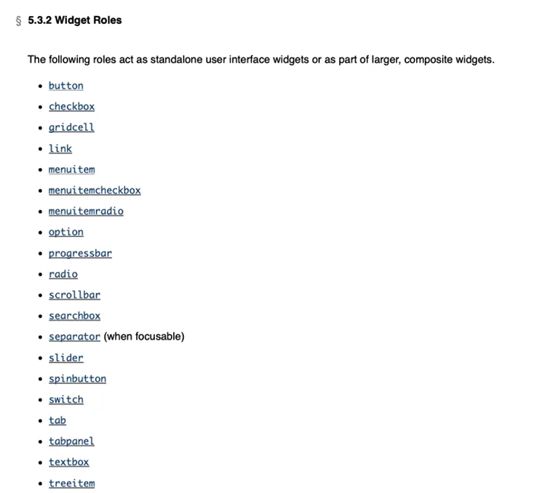

Composite widget roles – there is a very strict hierarchy when it comes to composite widgets, these have to be composed with very specific standalone roles and often in a very particular order. In most cases, we can’t pick and choose which roles to use as a composite widget, since some standalone roles can only exists as a child or nested in one of these nine composite widget roles.

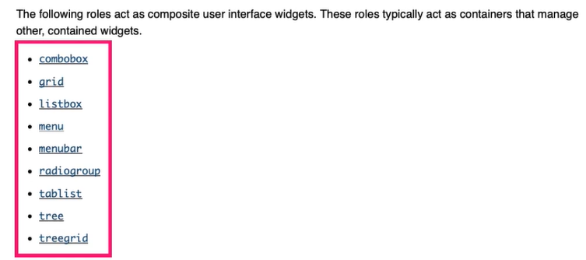

Document structure roles provide content organization. Most of them are not interactive but provide semantics for content like headings, images, list and tables –

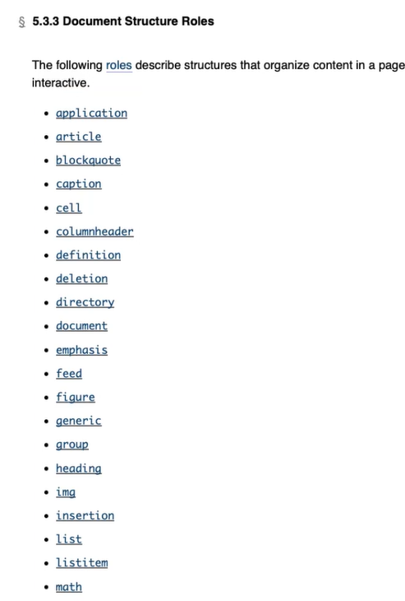

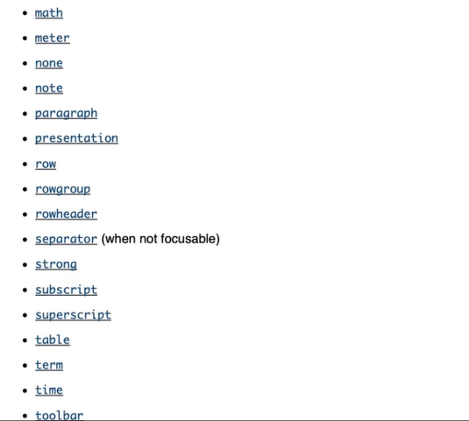

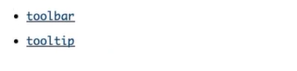

Live region roles – for pieces of information that gets updated dynamically like scores board, chat logs, timers and messaging.

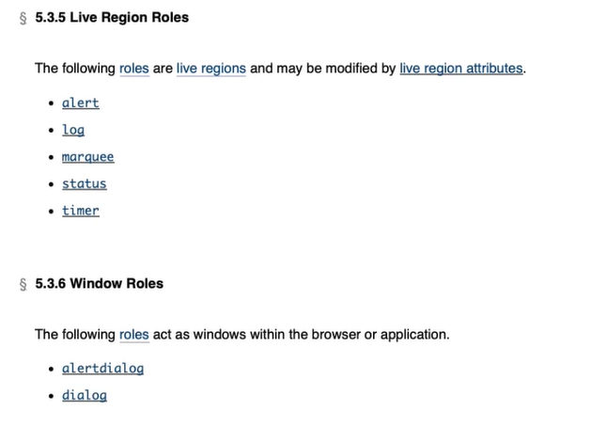

We can have certain attributes for widget, live region, drag-and-drop and relationship attributes –

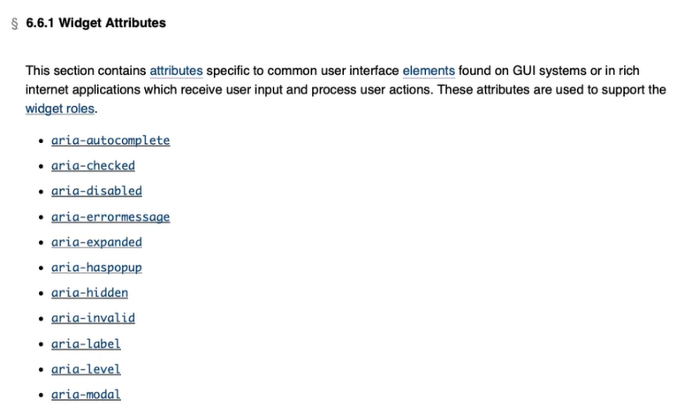

States and properties of ARIA –

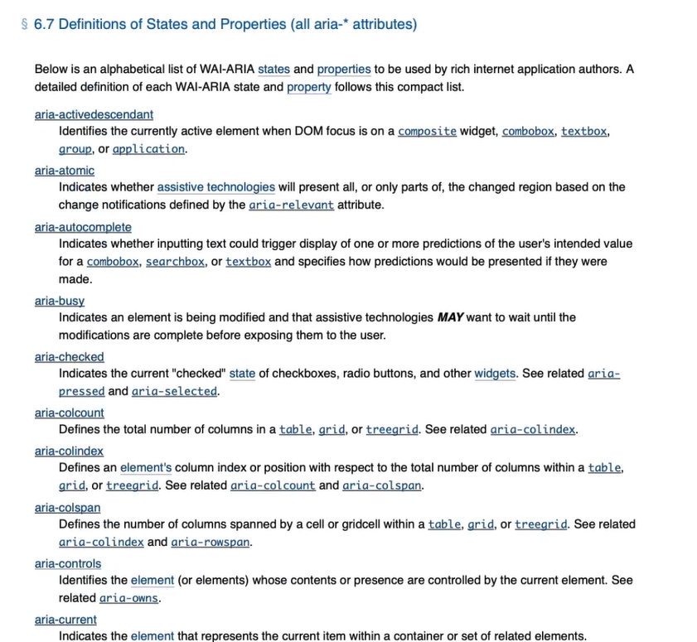

ARIA is used to describe widget roles, semantics and state.

5 rules of ARIA – First rule of ARIA is don’t use ARIA if you can use HTML instead like below –

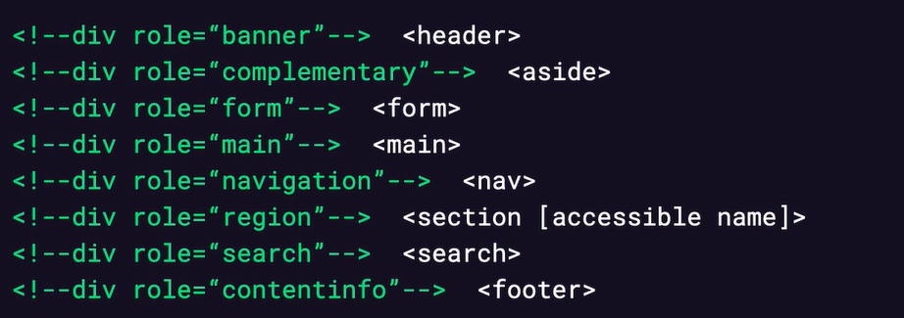

Second rule of ARIA – do not change native semantics like below if user tries to press SPACE key then nothing will happen –

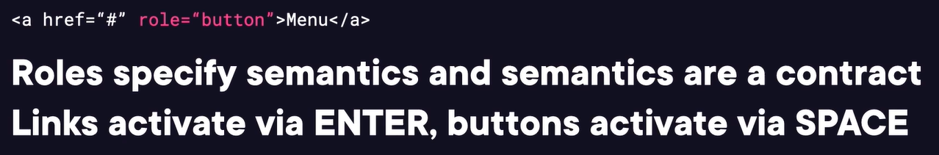

Rule 3 – all interactive ARIA roles and need to be operable by keyboard.

Rule 4 – Don’t use role as “presentation” or aria-hidden as true on visible focusable elements.

Rule 5 – All interactive elements must have an accessible name.

ARIA authoring practices guide (APG) – we can refer it in terms of working examples for different component patterns.

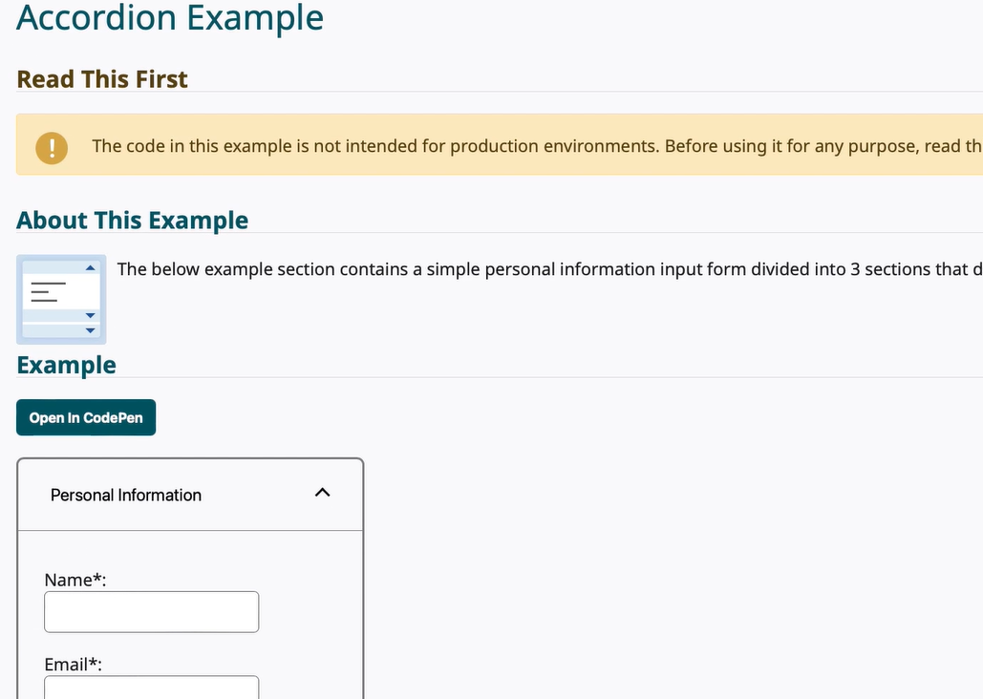

ARIA patterns do not support mobile or touch devices.

No ARIA is better than bad ARIA, if you don’t know, just leave it alone. Home pages with ARIA present had over twice as many errors (57 on average) than pages without ARIA (27 on average).

Building a custom menu button – semantics

Selects are for providing input as part of form, not for actions. Menu buttons are for dynamic actions, Menu buttons are not for navigation or forms.

There is a menu button pattern which we can use for a button like a push button which opens a menu –

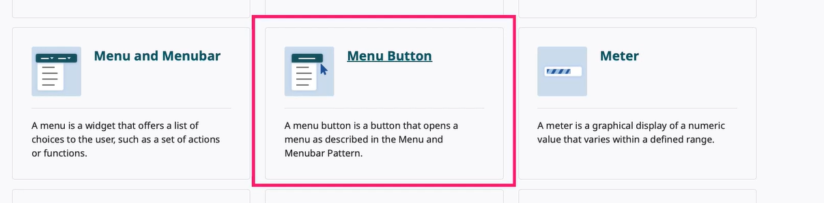

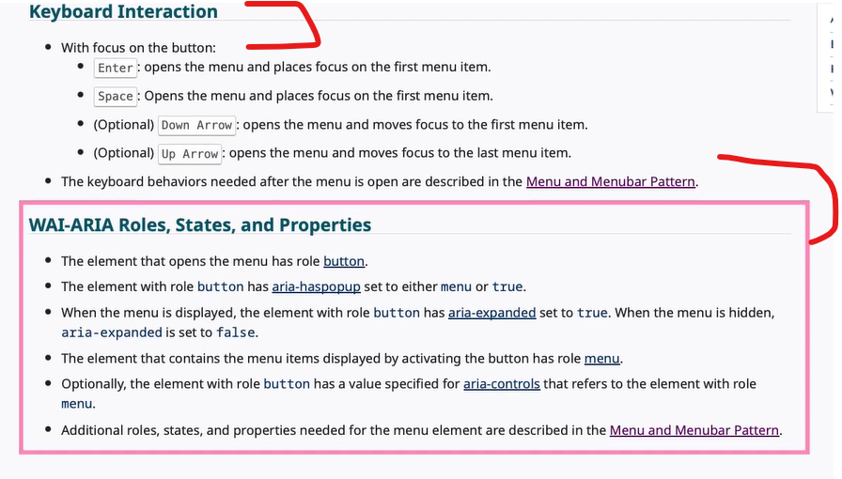

Semantics – express what something is. Every interactive control must provide the following three things – name, role and value. Semantics provides roles.

Roles do not provide any interaction but just what something is. Like if we apply role as button on <h2> element, then it will be focusable by tab and also spell as button by screen reader but won’t get clicked if we press SPACE or ENTER key. We need to provide interactions. Instead of applying further by using tabIndex as 0 for focus, listeners for SPACE and ENTER key press, as a proper fix, we should actually button element itself. Learn HTML – let the platform do the heavy lifting for you. ARIA should only be used to fill in gaps that HTML does not provide.

ARIA also provides states and properties to further describe interfaces to assistive technologies. Out of name, role and value for semantics, ARIA states and properties help provide the “value”. It is important because dynamic visual changes must be presented programmatically.

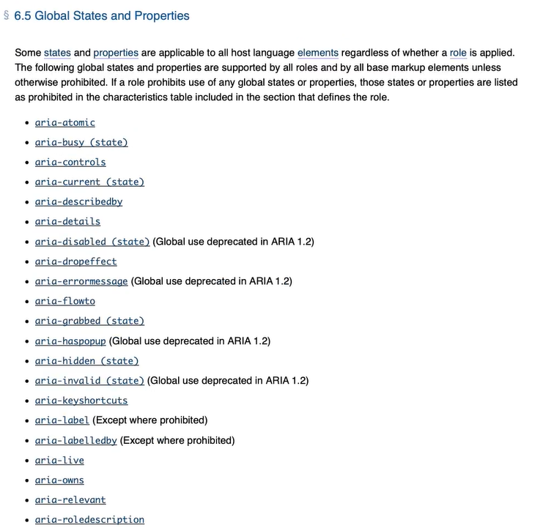

For button below are available –

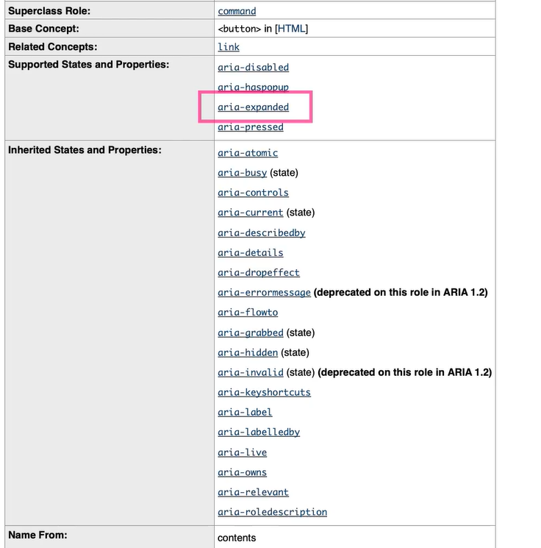

The aria-hidden will remove the element from the a11y tree but it will still be there on DOM tree.

Tooltip, accordions, expandable list are not considered as pop-up. We can add hasPopup to a button which can show a popup of available menus –

Accessible name calculation priorities - aria-labelledby, aria-label, text content, title (not recommended). It provides the “name” feature out of three core items of semantic principle.

The role as “presentation” completely strips the semantics form an element, we should not apply it on the visible and focusable element, instead of role as “presentation” we should use role as “none” which is more semantic meaning over. It is useful for honoring the parent-child relationship when we want to remove a middle element from the hierarchy –

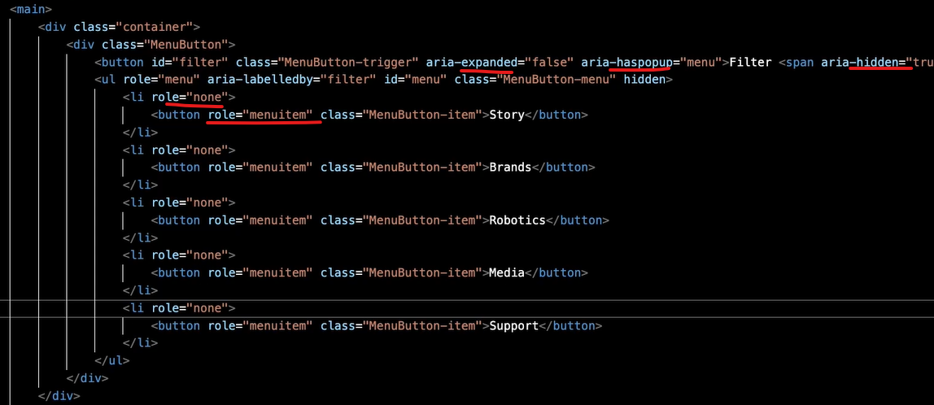

Keyboard support details from APG guide –

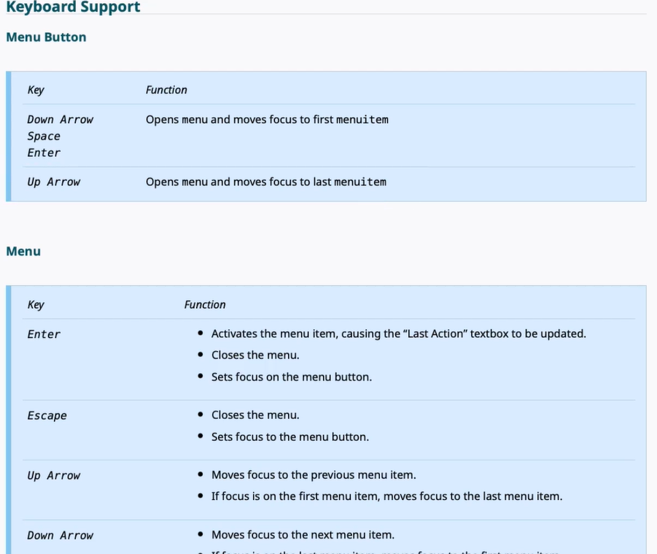

TAB key moves interactive element to interactive element, ARROW and other keys move within the composite.

Menu item variations – menuitemradio vs. menuitemcheckbox, menu doesn’t have any state unlike radio or checkbox like when we do selection it made the item “selected”, we need to manually write the code for aria-selected as true or false.

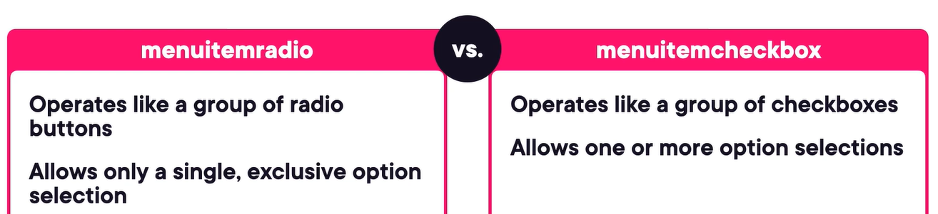

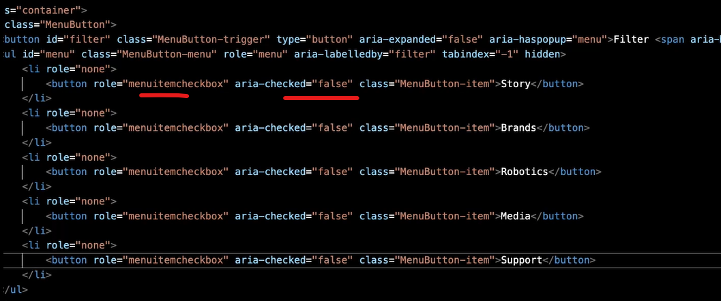

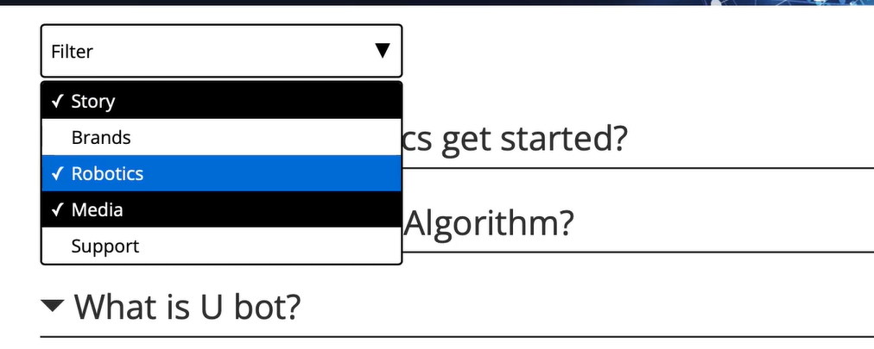

Testing – start with first a11y tree –

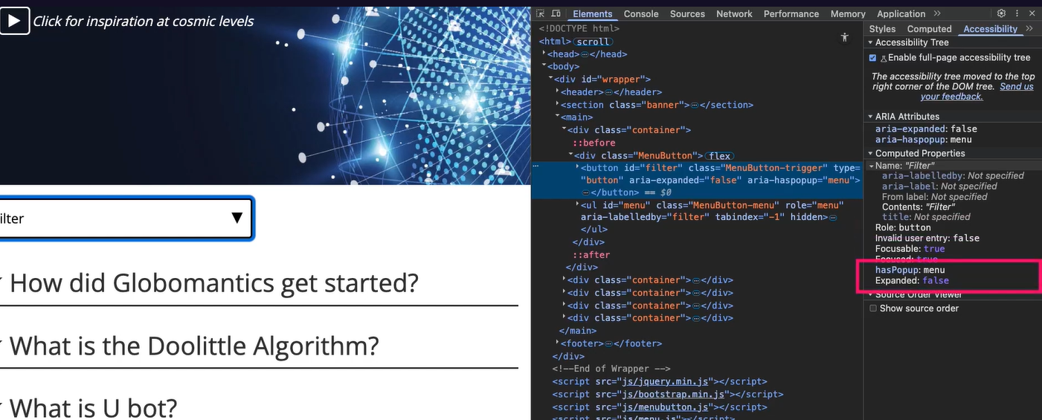

Different screen readers will announce differently, they have implemented them what they feel is best for their customers –

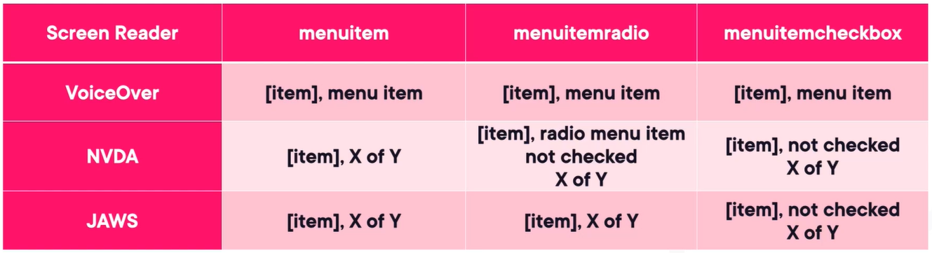

# Web Components: Framework Integration

Web components are browser-native technology, to create framework independent components, write ones deploy everywhere. They are built upon Custom elements, shadow DOM, HTML templates and ES modules.

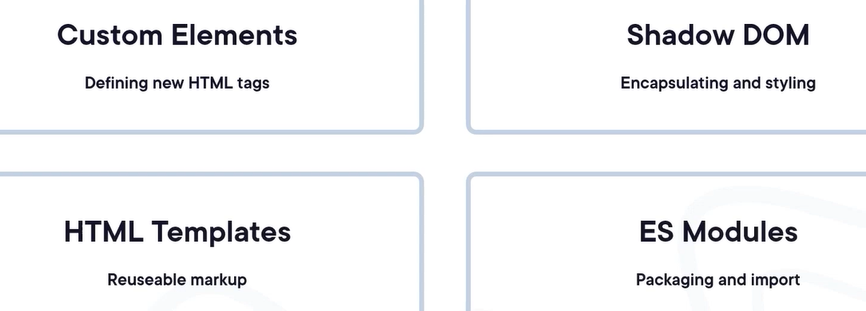

For a custom popular component built in React, if we want the same thing in Angular or Vue, instead of creating three libraries, we can built our component once as a custom elements, then integrated anywhere using standard HTML syntax in any framework of choice.

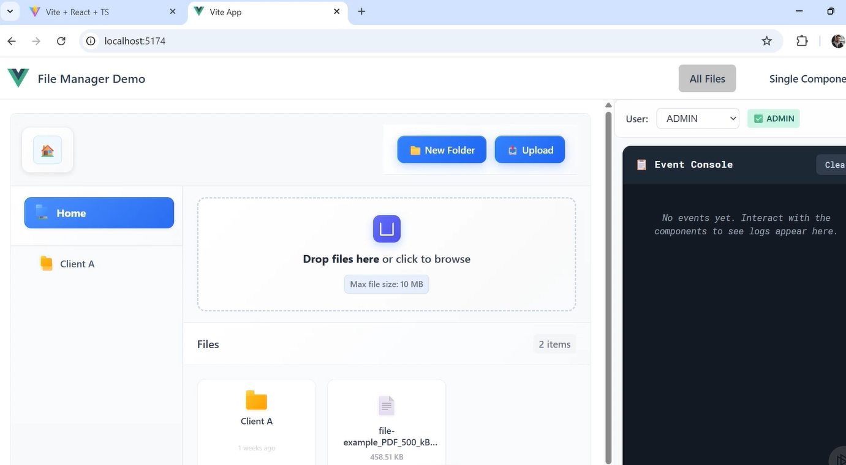

Web components build artifacts –

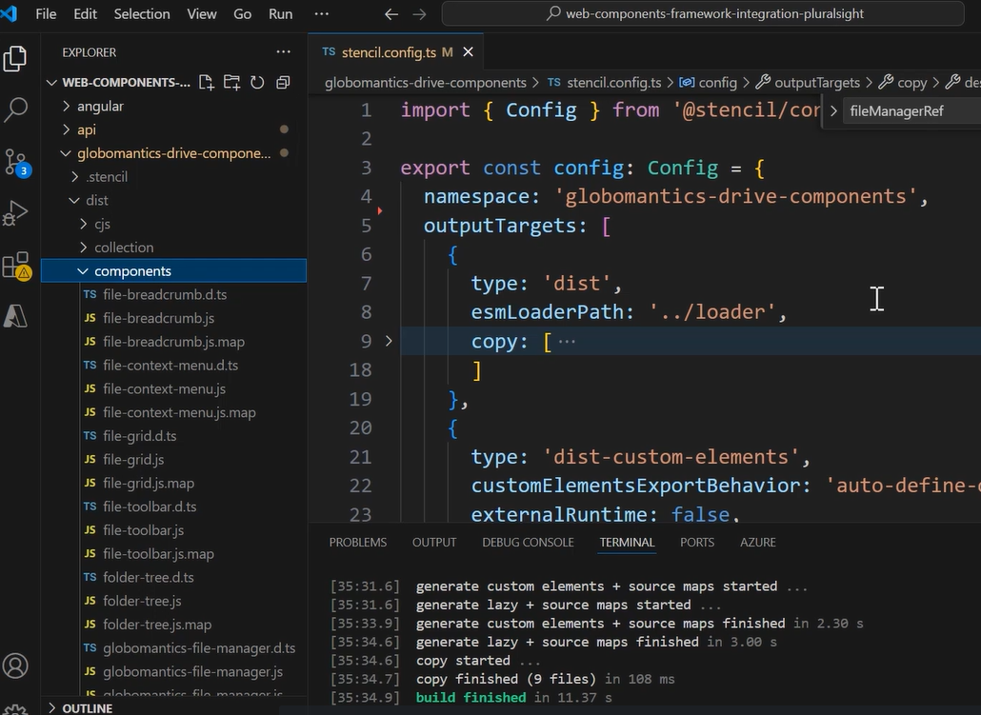

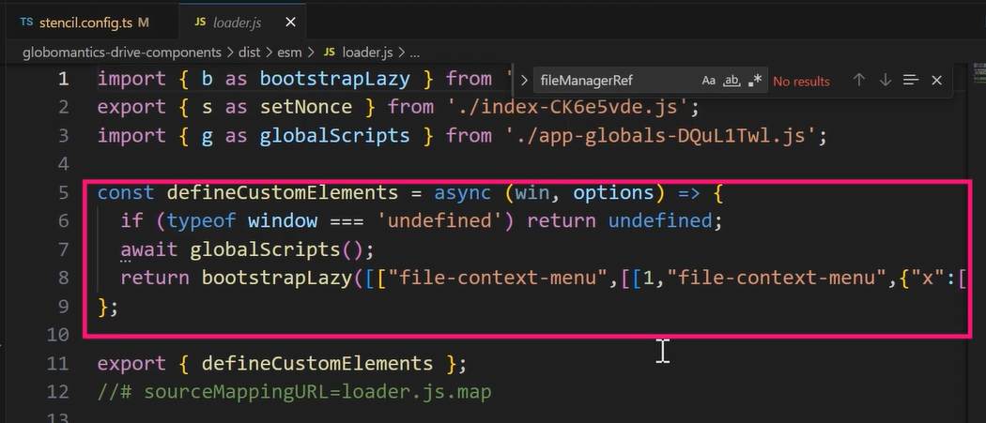

Using web component into Angular – we also have to use CUSTOM_ELEMENTS_SCHEMA to tells angular template compiler to relax and not validate unknown HTML elements or their properties or events as Angular needs to know them compile time but they are dynamic and they get register themselves at runtime after angular already compiled our templates –

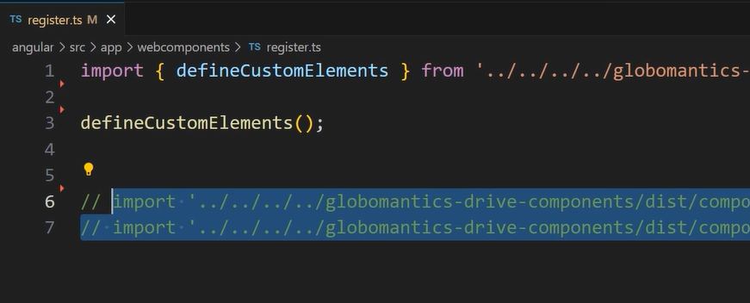

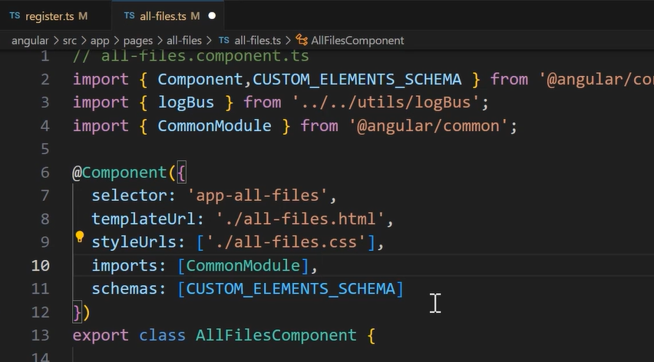

Handling two-way data flow with Web Components –

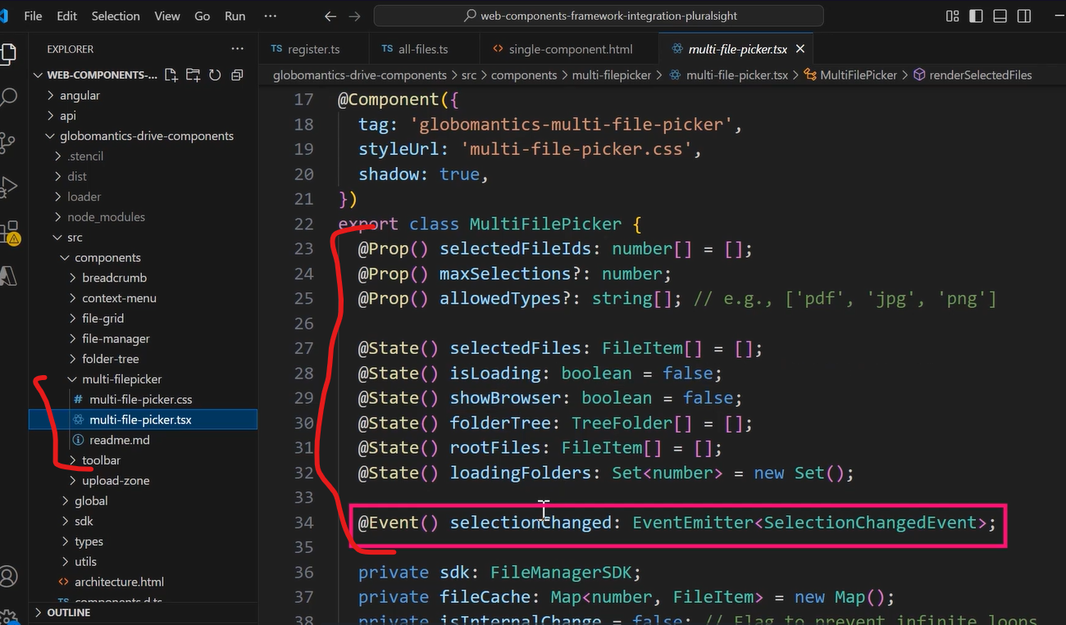

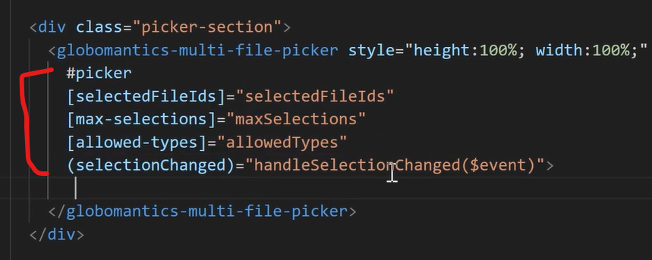

In below, the custom components is raising events as a part of several hooks, if any consuming component subscribed to it then the custom component logic will be ignored –

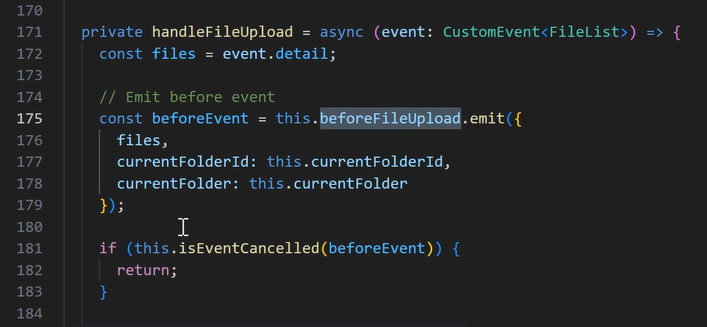

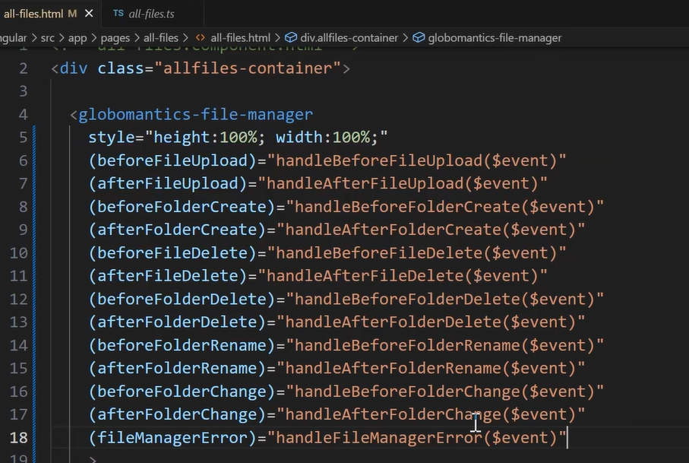

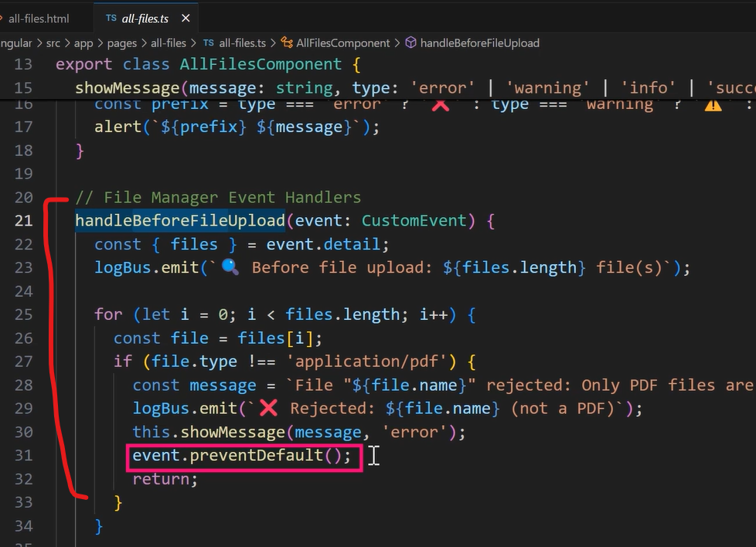

Customizing web component appearance with slots –

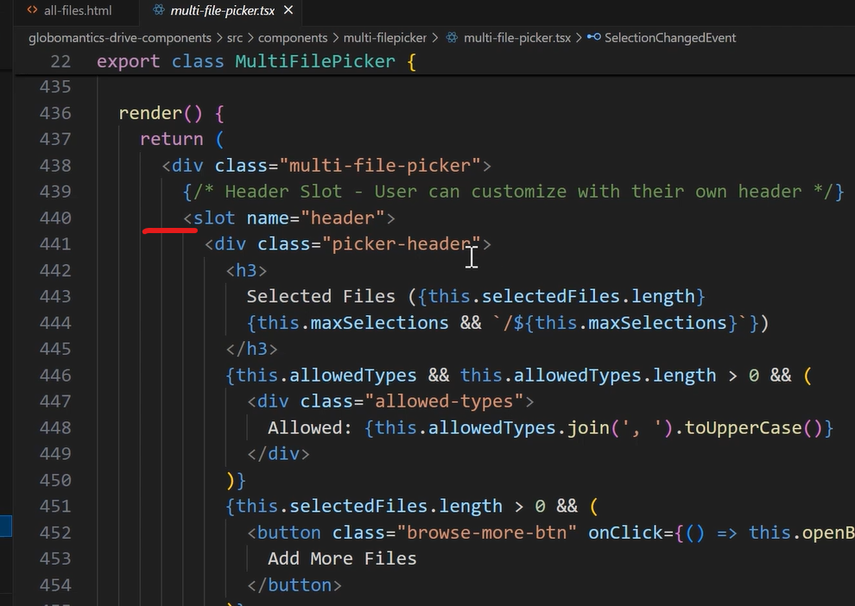

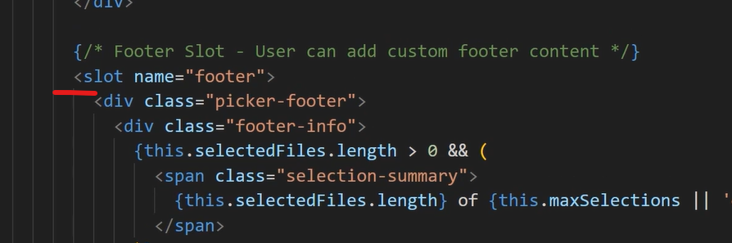

Now from our component we can override the slot content –

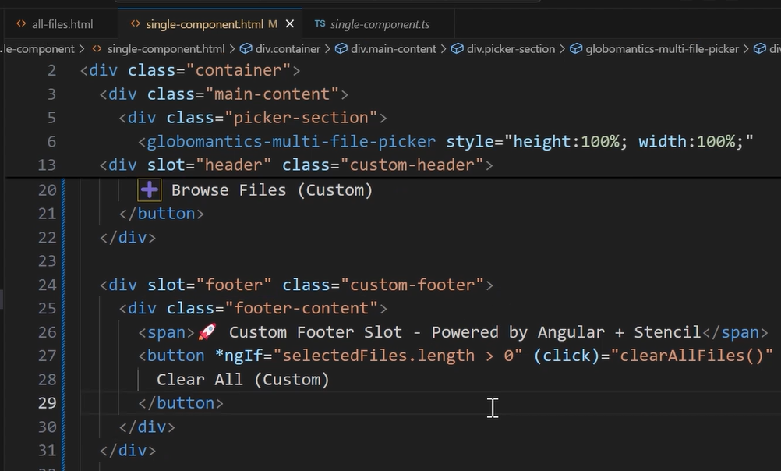

Using web component into React –

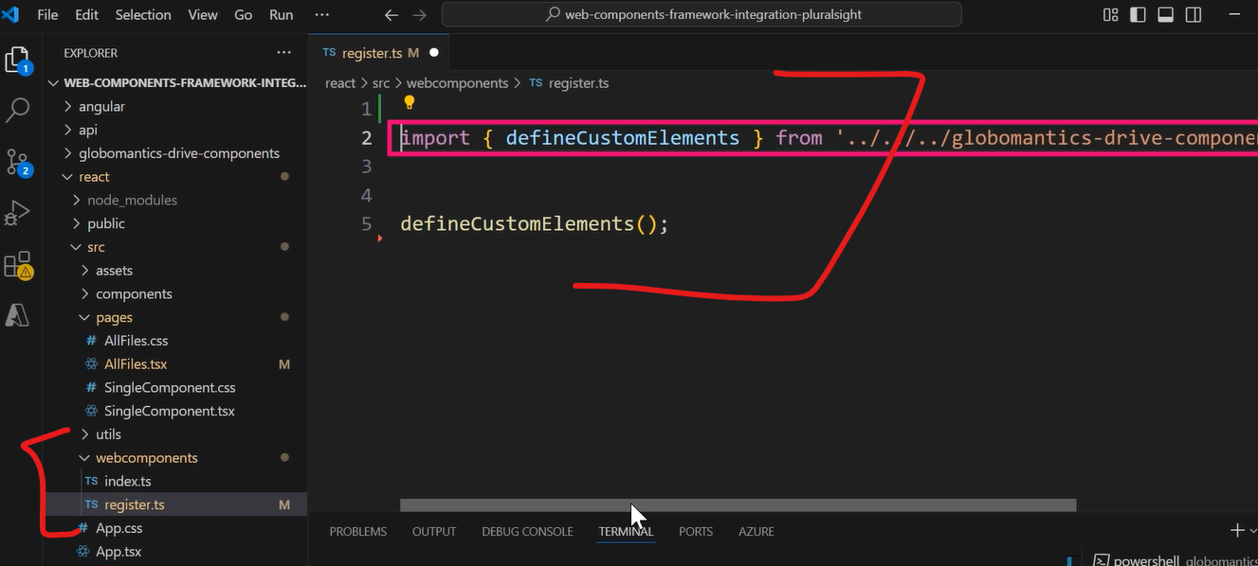

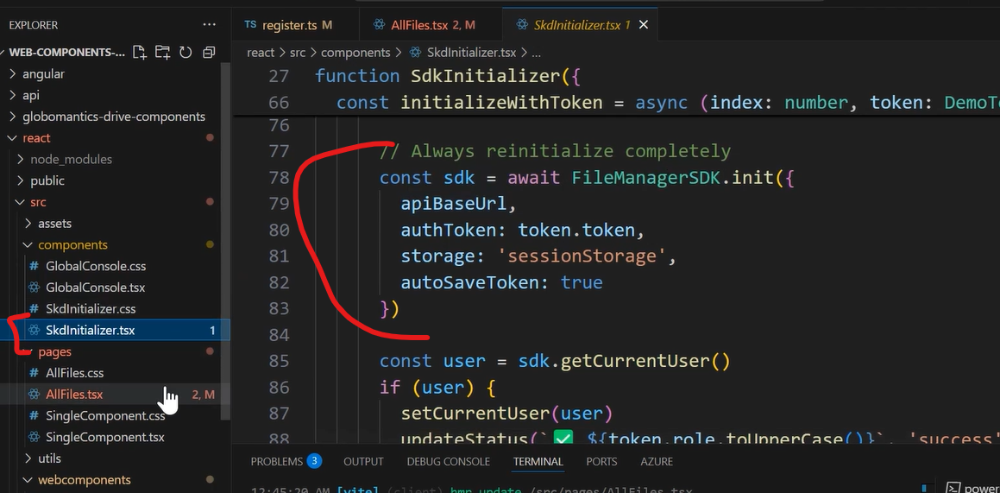

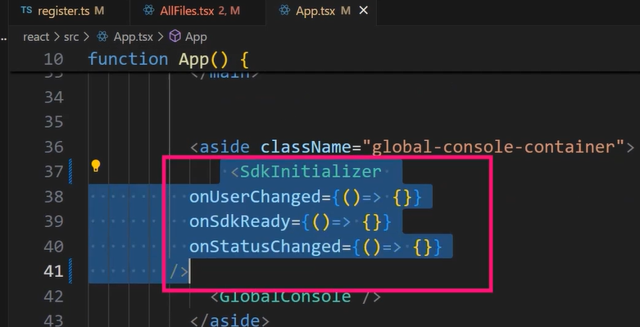

Handling two-way data binding –

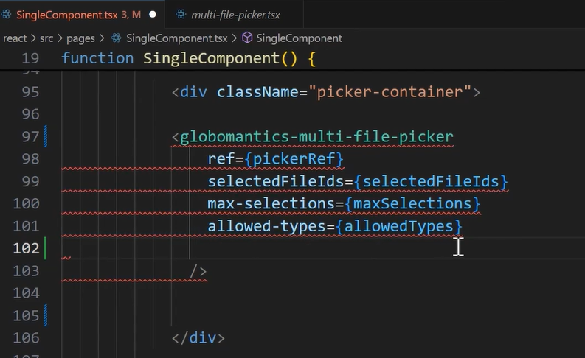

AI-powered React Applications: Building Intelligent

# Interfaces

Full-stack Java Development with Play Framework and

# React

# UX Best Practices

Tighten your spacing. Then tighten it again - Most interfaces don’t look cheap because of color or typography. They look cheap because everything sits too close or too far apart, like the layout was arranged by someone who just eyeballed it while half-asleep. Pick a spacing scale and stick to it. Something predictable like 4, 8, 12, 16. It doesn’t matter which scale as long as you commit. If your layout spacing looks like 7, 13, 19, 22 and 9 pixels all mixed together, congratulations, you’ve just invented visual chaos.

Keep icons consistent

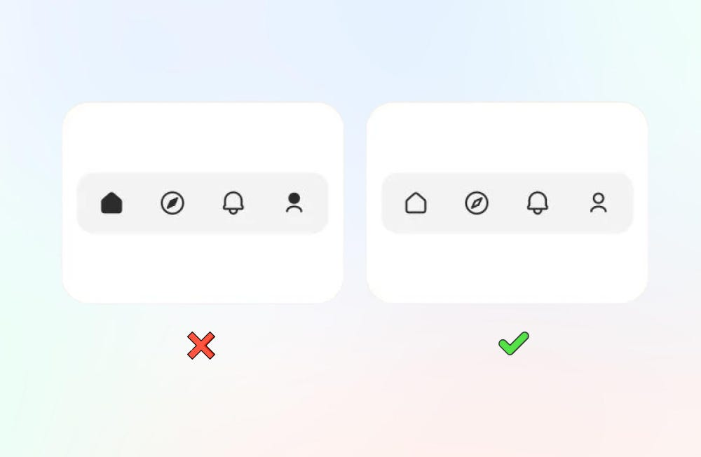

Fix your alignment

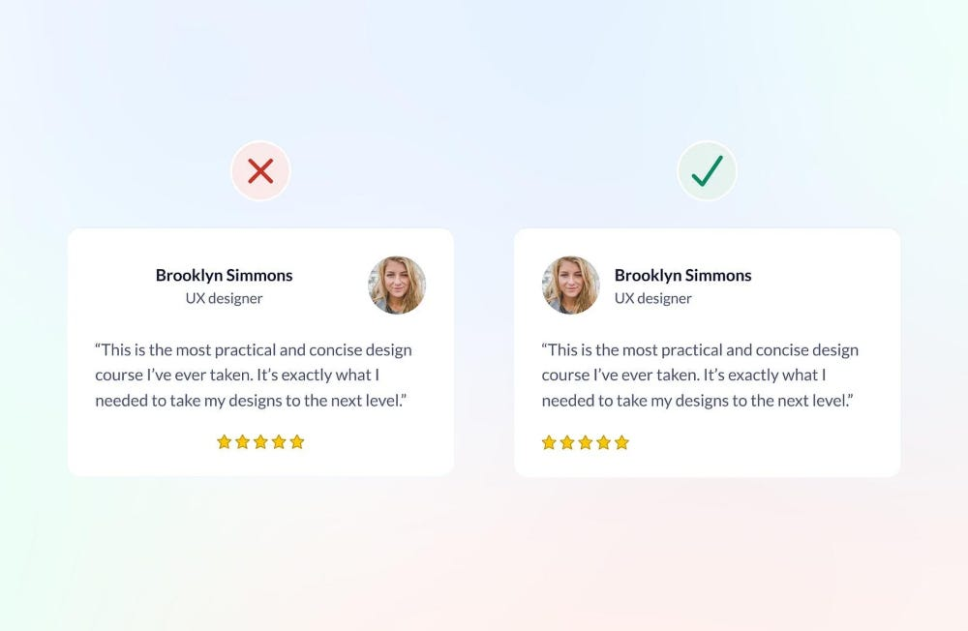

# What Is React?

# Chrome Dev tools features

Network blocking –

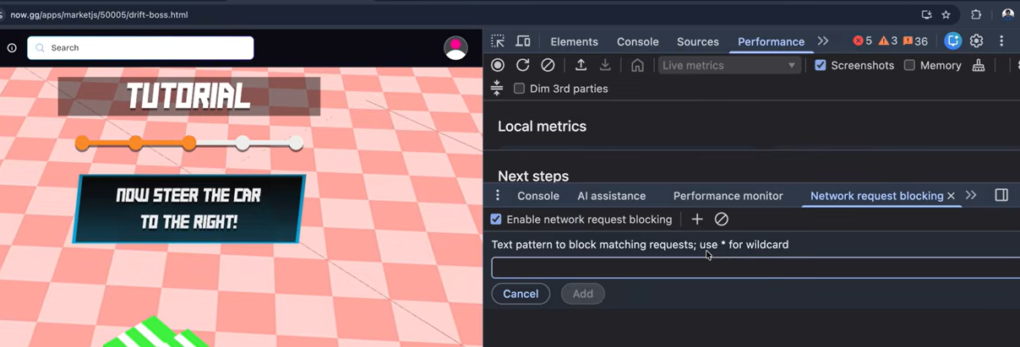

CSS overview –

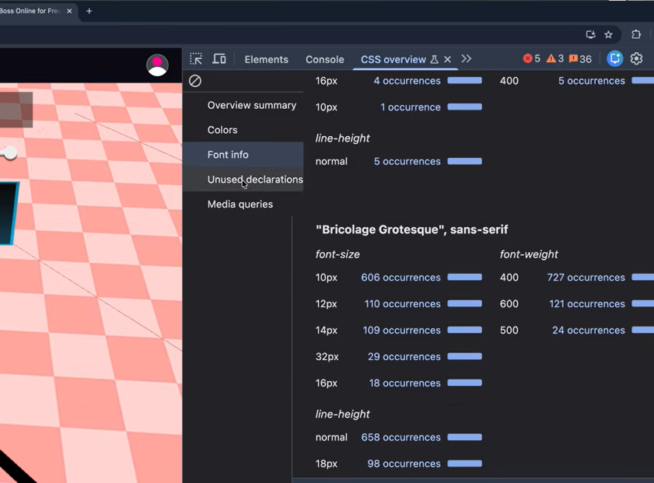

WebAuthn authentication simulation –

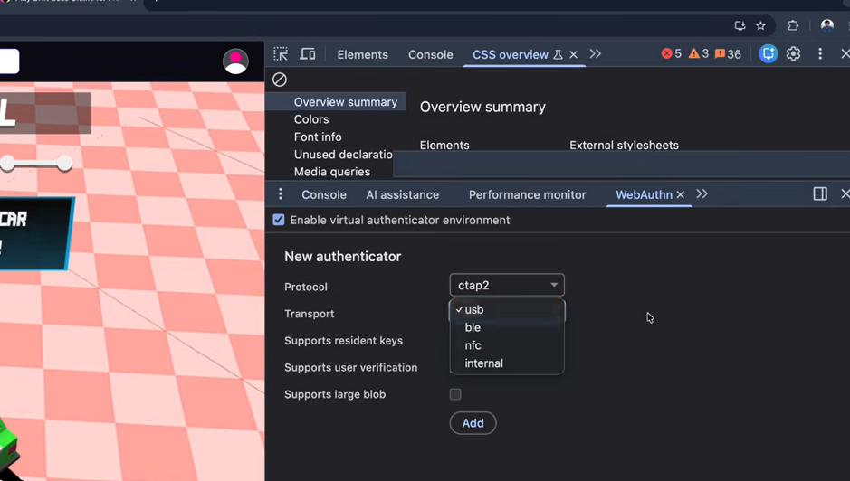

AI assistance to get insights from console log –

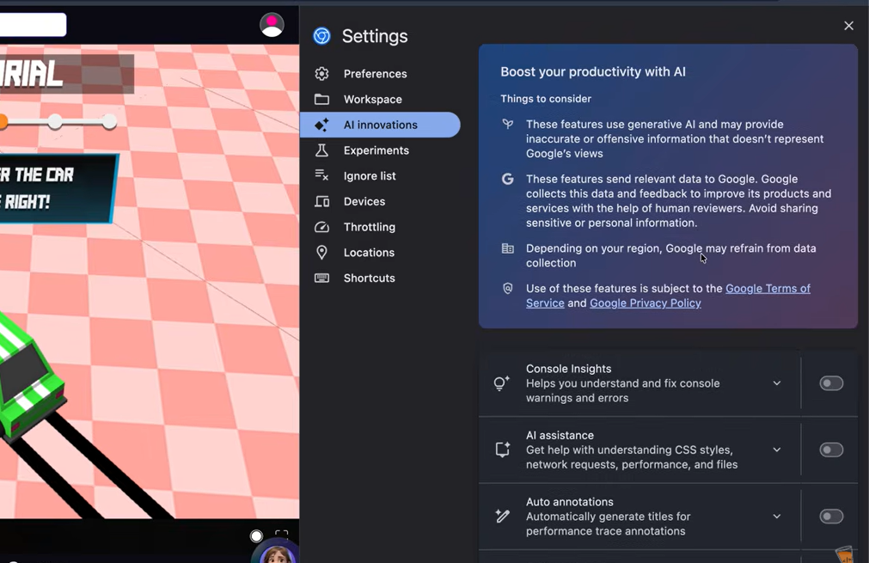

# React Native: The Big Picture

It enables us to build rich mobile native apps on both iOS and Android.

React Native is built using both JS and React.

JSX stands for JS expressions, it is a preprocessor step that adds XML syntax to JS.

# UX

Spacing is a Superpower (aka the 8-point rhythm) - Consistent spacing makes the UI feel intentional rather than “off”. The article recommends using an 8-point scale (0, 4, 8, 12, 16, 20, 24, 32, 40, 48…) rather than ad-hoc margin/padding values.

Using buttons shapes and colors – Shapes speak before words. Circular buttons communicate approachability and continuity, while rectangular ones suggest stability and order. Rounded corners soften perception, reducing cognitive load and perceived risk, an effect confirmed by visual ergonomics research showing that the eye tracks curves more comfortably than sharp angles.

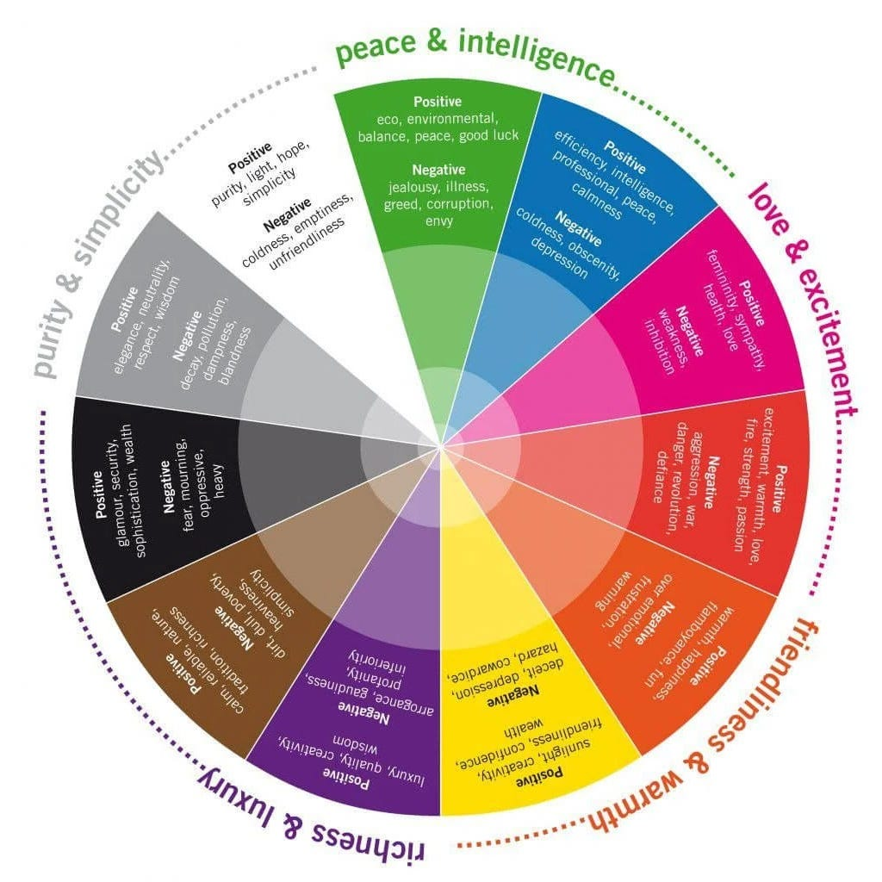

## Signals vs. RxJS Observables –

**Angular Signals (push-pull hybrid)**

**Pros:**

* Avoids redundant computations: dependents marked “dirty” but recomputed only when accessed.
* Built-in equality checking prevents unnecessary updates.
* Dynamic dependency tracking: only active branches are tracked; unused code/branches don’t trigger computations.
* More stable intermediate state; reduces flickering and transient inconsistent values.
* Easier to reason about in complex UI dependency graphs.

**Cons / Caveats:**

* Implicit dependencies can make debugging harder if you’re not careful.
* Slightly more complex internal implementation (push-pull hybrid), which may be opaque to new developers.
* Developers need to use utilities like untracked() to avoid unwanted tracking in some cases.

**RxJS Observables (pure push)**

**Pros:**

* Very flexible for asynchronous event streams (timers, HTTP, user events).
* Mature ecosystem with operators for filtering, mapping, combining streams.
* Explicit control over subscriptions and unsubscriptions.

**Cons / Limitations:**

* Redundant computations possible if multiple paths depend on the same source (“diamond problem”).
* Emits even unchanged values unless manually filtered (distinctUntilChanged).
* Reactive graph is static; unused branches may still consume resources unless explicitly unsubscribed.
* More boilerplate / manual management required in complex dependency trees.

**TL;DR Recommendation:**

* Use **Signals** when working with state and UI updates inside Angular: more efficient, less boilerplate, automatic optimization.
* Use **RxJS** for asynchronous event streams and complex stream operations outside of UI state updates.

Signals (hybrid push-pull algorithm):

Uses a mechanism where producers, when changed, mark dependents as “dirty” but don’t immediately recompute them. Then consumers pull values when needed, which allows caching and avoids recomputing the same node multiple times when multiple paths lead to it. Angular signals also use versioning.

Advantages of signals here:

Less computational overhead due to avoiding duplicate work.

More stable state (no flickering) because values are recomputed only when actually accessed.

. Propagation of equivalent changes (when new value equals old) - Signals:

Have built-in equality checking (using Object.is by default) so setting to an equivalent value does not trigger invalidation / marking dependents dirty. Also, you can provide custom equality functions on signals or computed values.

Dynamic restructuring of the reactive graph - Dependencies are discovered dynamically during evaluation (“pull”)—only the parts of the graph that are actually used are accessed. If in a computation the code takes different branches depending on state, only that branch’s dependencies are registered. Angular automatically tracks this. This means the reactive graph adapts, subscriptions / dependencies for irrelevant branches are not held.

## Modern JavaScript Build Tools

What build tools do - Transpiling -> bundling -> minification.

Transpilers – allow us to write modern JS and TS but ship safe code that also older JS interpreters can understand.

Bundler – combines many JS files into one (or a few) in more optimized chunks to avoid too many network requests.

Minification – shrinks the final file size to load them faster by removing spaces and reducing variable name.

Earlier we used to do all these things by ourself by using Grunt or Gulp task runners but now we just use Webpack as it can configure almost everything like Loaders, Plugins, code splitting but it has lots of config to deal with but recently we have Vite and esbuild which are fast and opinionated as they use smart default and have things like hot module replacement.

These new tools are designed after modern JS become standard, rely on native ES modules during development which simplifies tooling and speeds things up.

Vite and esbuild do the same thing but for different environments – Vite is build with modern developer in mind, uses native ES modules in the browser during development, no need to bundle just to run our code, only processes the files actually used on the page, which causes a very fast dev server. It also supports HMR (updates only the changed modules, not the whole page, styles updates right away). Vite is able to do all of this because it uses native ES modules, fast dependency tracking and uses esbuild for some of its internal tasks). It also uses lots of plugins system which are built on Rollup.

Esbuild is around since before Vite took off, all about raw speed and written in Go, optimized for performance, transpiles and bundles in milliseconds. Unlike as Vite it doesn’t give scaffolds projects, nor manages plugins nor opinionated but esbuild offers a clean API, CLI, and the ability to build exactly what we need. That’s why Vite uses esbuild under the hood for tasks like transpiling and pre-bundling.

Developers who need complete control or who are building a tooling for themselves often reach for esbuild first –

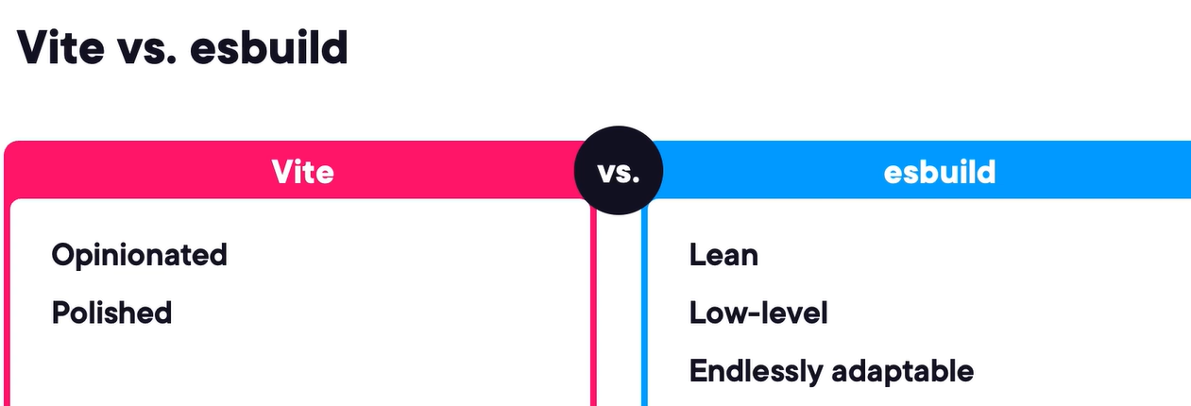

How Vite delivers instant feedback – uses native ES modules, servers individual files as modules then the browser handles the loading, that’s why if we just change one file only that file is reloaded and not the whole app and that’s how it achieves such a fast hot module replacement.

HMR is built into Vite’s dev server, uses native ES modules and reloads only the changed module.

The config file for Vite – server port, custom build options, path aliases, environment variables.

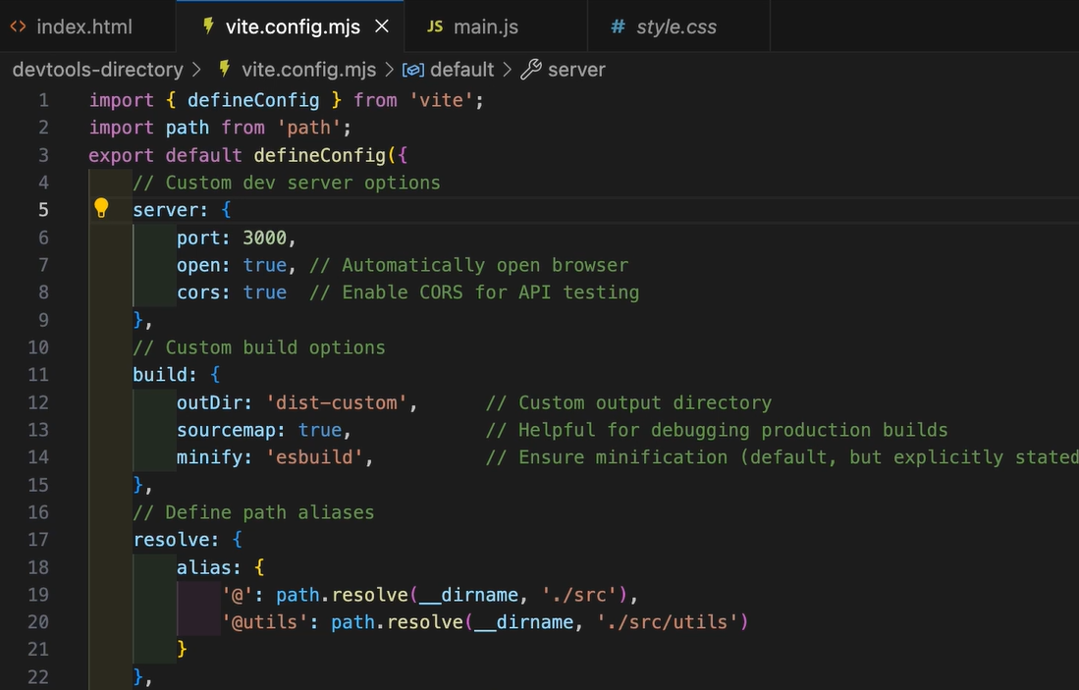

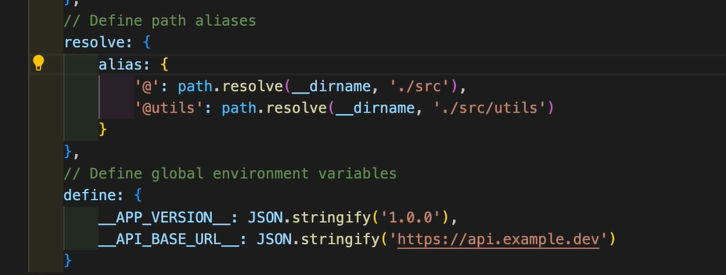

During development Vite doesn’t bundle at all, it uses native ES modules, only loads what we need that’s why it has super fast **reloads**. But for production Vite switches to Rollup to bundle our entire app and optimized for fast **loading**.

We can also provide manual code splitting for specific libraries like below maybe for caching reason and reducing bundle initial size –

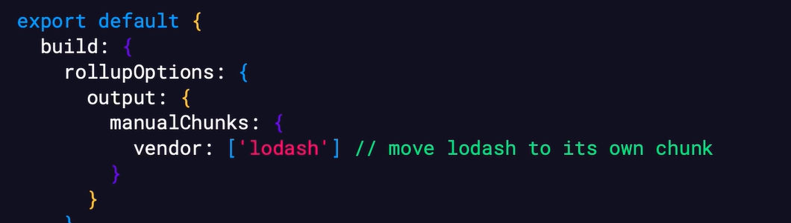

Through Vite we get best of both worlds –

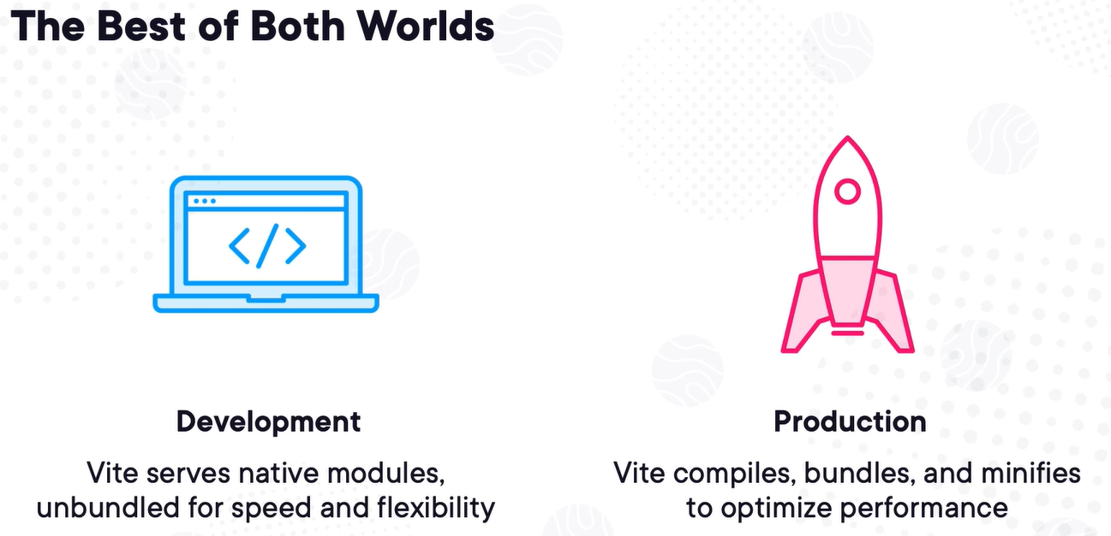

Production vs. Development mode – in production mode, Vite is focused on performance and compatibility. Not speed of iteration.

To improve the performance, Vite pre-bundle the dependencies using esbuild which converts CommonJS or unoptimized modules into fast-loading ESM and caches them. This speeds up server start time and HMR. If you add new dependencies later, Vite automatically updates the pre-bundle.

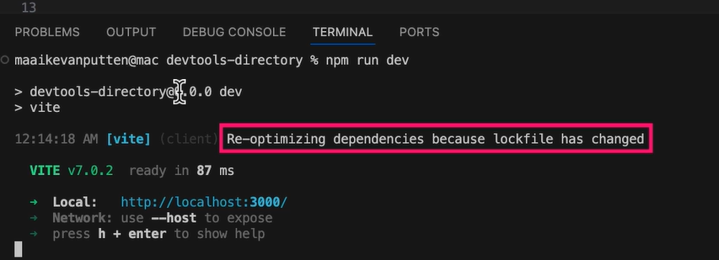

We can also provide which package to include and which to exclude if any package gives error on startup which might be rarely needed –

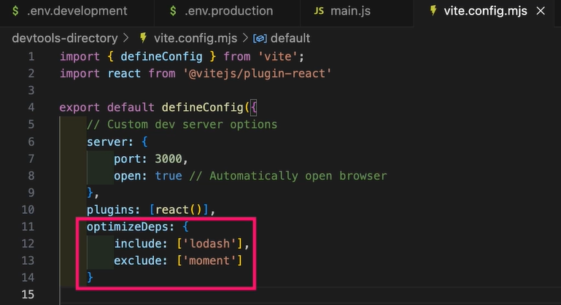

The esbuild – if we want raw speed and full control. Vite gives us a full dev server and plugin system, but esbuild is at lower level, it doesn’t assume much about our setup, we can use it for custom build pipelines, static site generation, library packaging and speeding up complex dev workflows. Vite uses esbuild under the hood for typescript transpilation and JSX transformation. We can use it directly for fast production build.

The main benefit of using esbuild is that it transpiles code quickly and correctly. Transpiling is not compiling but rewriting source code into a slightly older or simpler form. Necessary because not all browsers support the latest syntax, TS and JSX aren’t valid until they are transpiled.

We can have a build.js file to have all the config related to build and refer it in the package.json build script –

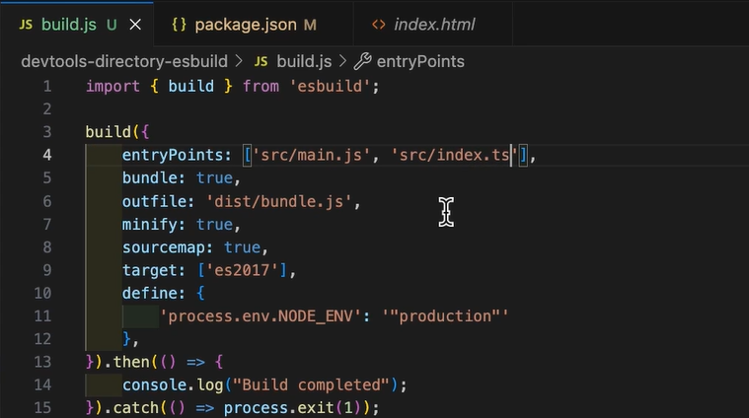

Using esbuild plugins we can modify files before and after bundling, handle custom file types and inject logic into the build pipeline. To use plugins, we need to run esbuild programmatically not through just the CLI.

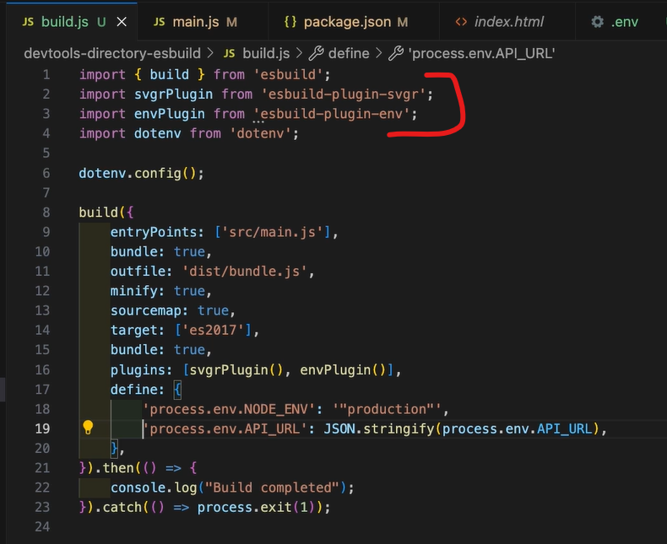

In performance comparison, Vite take longer than esbuild to build the application because Vite use rollup-based bundling and more advanced optimization options such as chunking, tree shaking and plugin hooks. But Vite is still fast because it focuses more on dev experience and advanced build logic unlike esbuild which adds some overhead. In short, both tool are excellent. Use Vite for dev server and use esbuild for production and CI pipeline.

Choose Vite if we want rich developer experience with HMR, if using framework like react and want opinionated defaults and minimal configuration.

Use esbuild if we need raw speed in our build pipeline, if we are building a package, CLI or internal tooling, if we want to scriptable, programmable build processes, if we prefer minimal dependencies and direct control.

Ideally, we should use Vite for our app and esbuild for component library or internal scripts.

Vitest is a blazing-fast test runner built for Vite.

Also, we can use rollup-plugin-visualizer and esbuild-analyzer to give insight into our final bundle size and what’s being shipped.

## Vitest Foundations

Vitest is a test runner made specifically for a Vite dev environment but it is not dependent on Vitest, we can add Vitest to any dev project.

We can also use keywords like “describe” and “it” instead of “suite” and “test”.

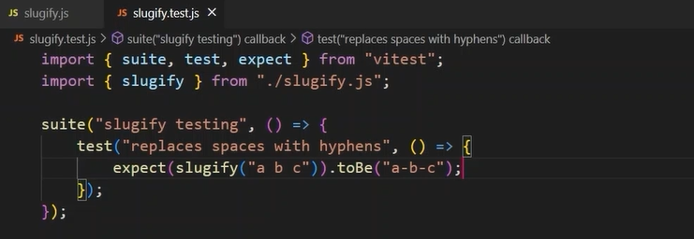

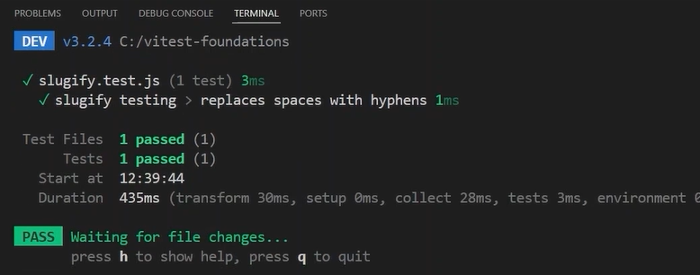

We can use test.todo, test.skip, test.only, describe.only for applicable scenario –

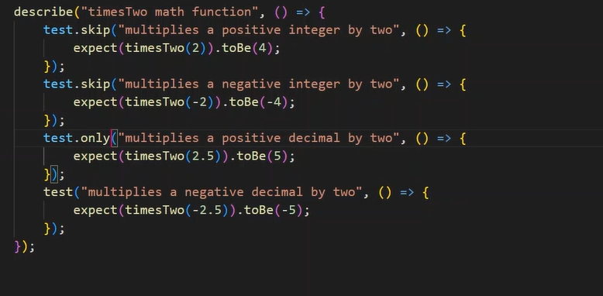

We can use test.each to avoid to many repetitive “expect” statements –

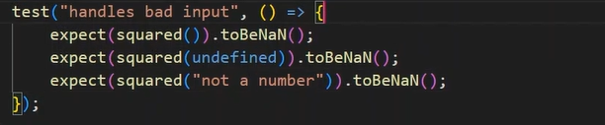

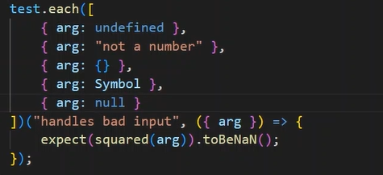

To catch the error the “expect” should be given a function that calls the function to test for exception –

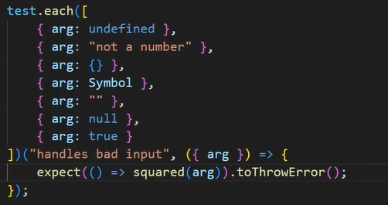

To provide custom configuration we can use vitest.config.js file, we can define different project grouping or colored output, and more –

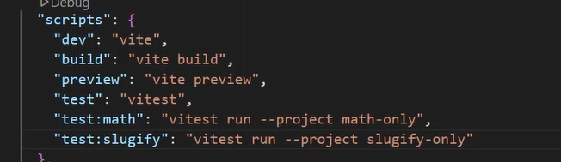

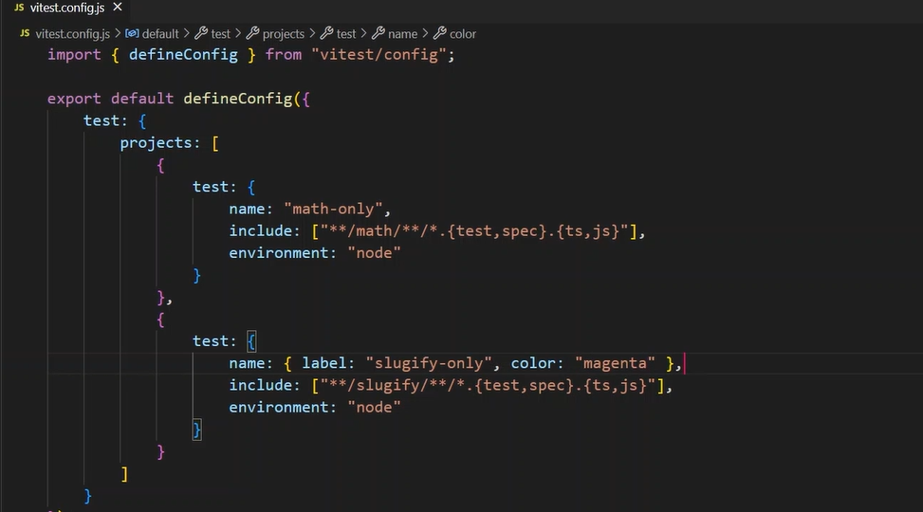

Setup and teardown –

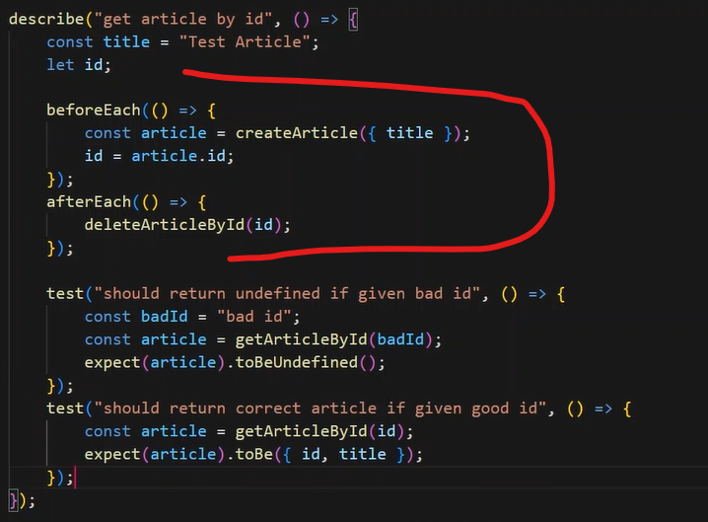

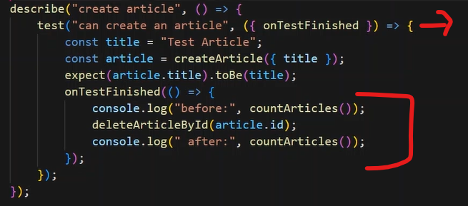

Asynchronous testing – the default timeout is 1000 milliseconds – using “await” keyword, if need more control then also use vi.waitFor()

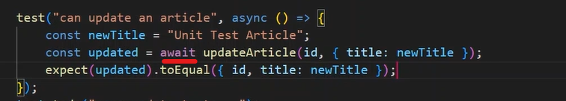

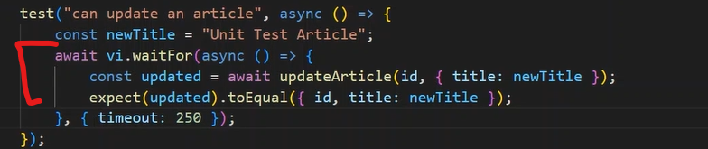

Spying and mocking –

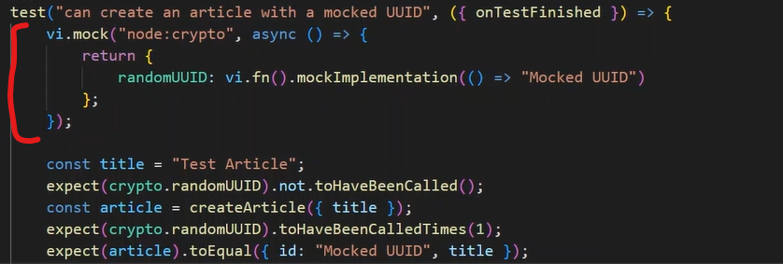

If we want to use all other methods from the actual file except a particular one, use below approach, also using mockImplementationOnce() will only give mock implementation for first time then it will call the actual service –

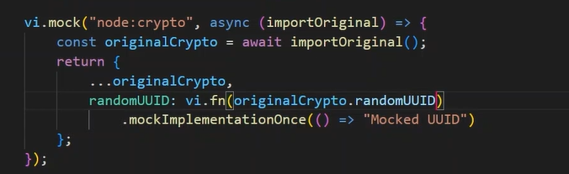

If we provide below setup were we are use mockImplementation() three times, then it will served respectively for first three calls accordingly to the sequence –

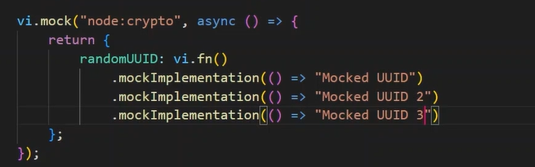

Browser testing – we need to use a separate vitest.browser.config.js file. It also creates screenshots automatically –

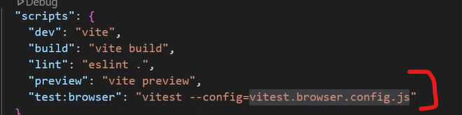

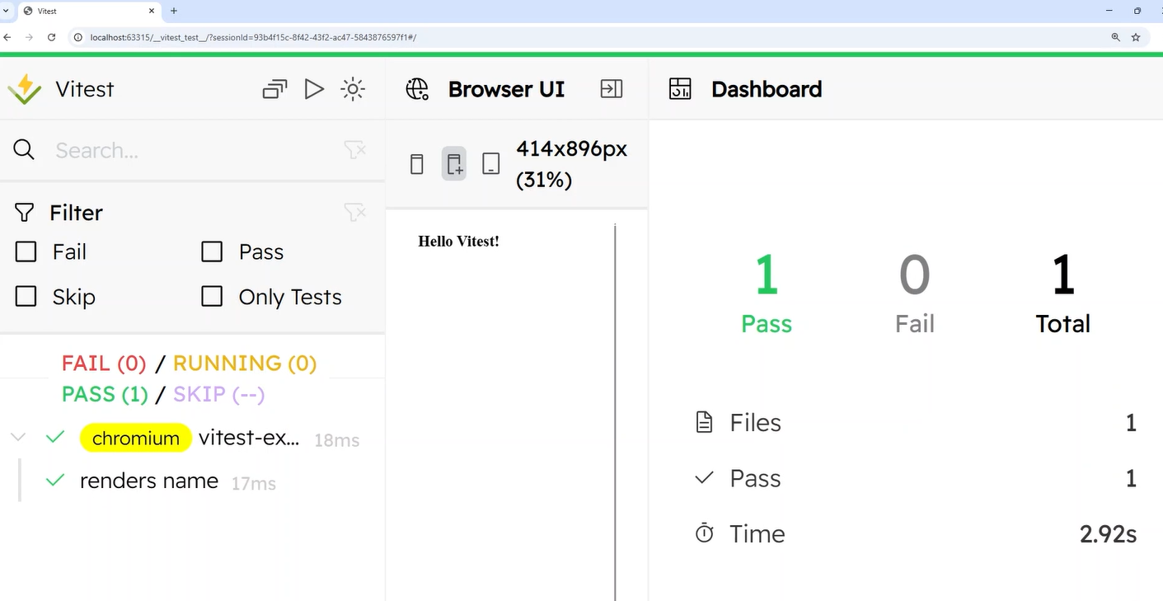

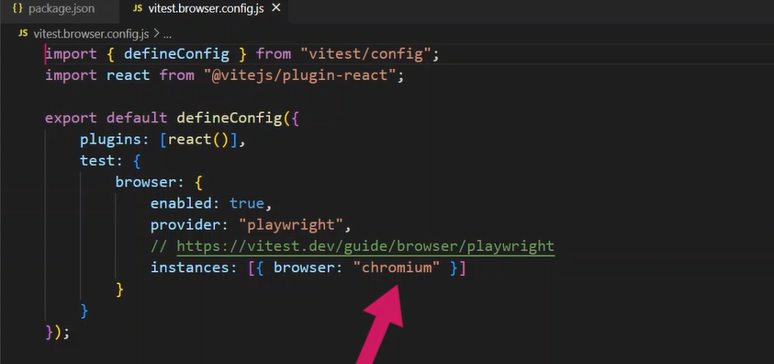

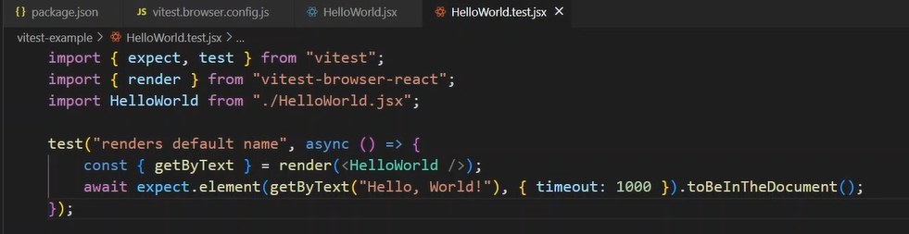

Locators and user events –

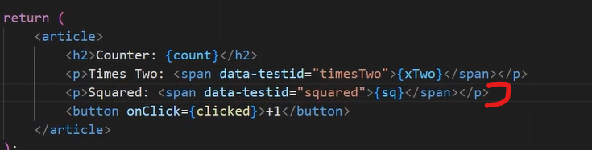

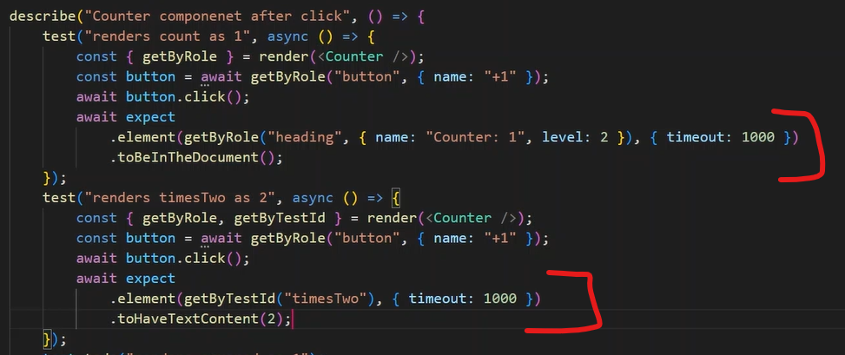

Reporting – by default it will show these parameters once tests are finished – transform, setup, collect, tests, environment, prepare

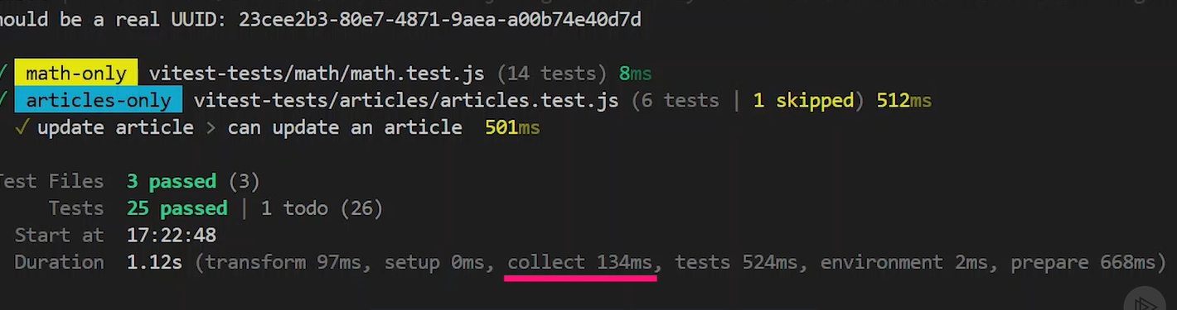

We can run cli command like – npx vitest run –reporter=verbose

Above command will show time for each test –

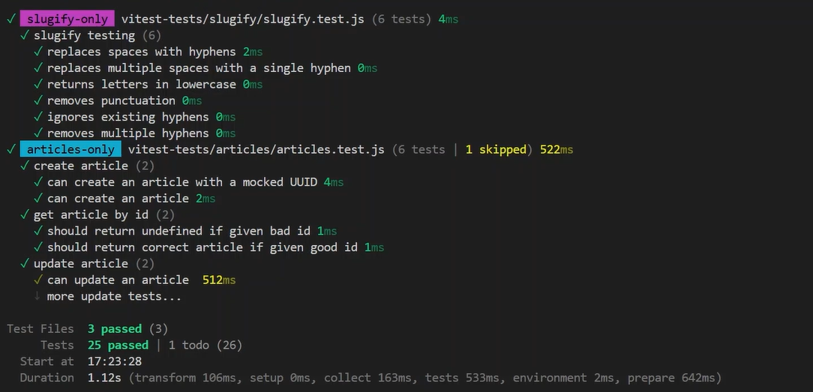

With “dot” flag we can see tests as dots –

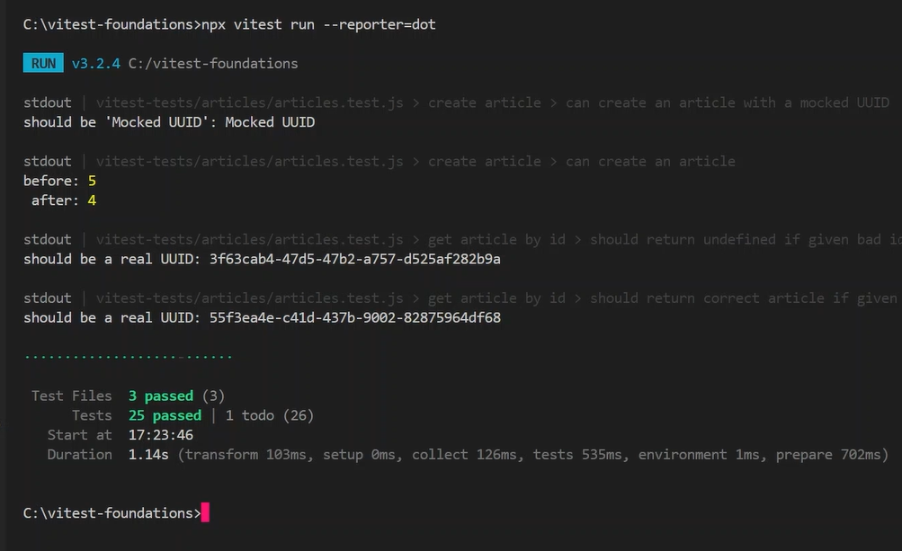

Using “coverage” plugin –

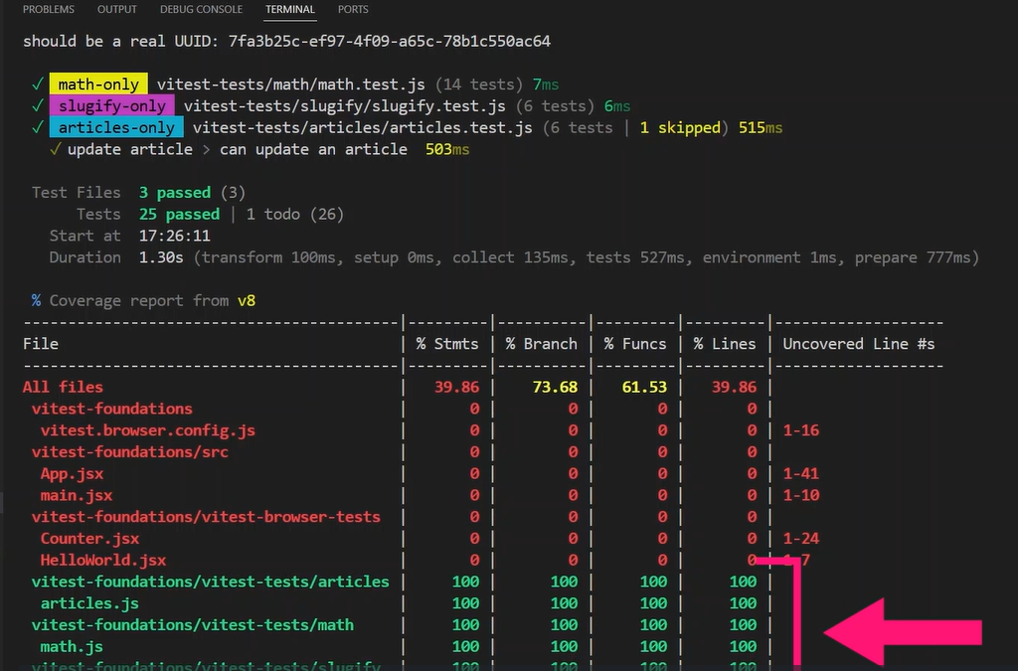

## UX Concepts: Information Architecture

Instantly familiar and easy UI vs. Lost and frustrated –

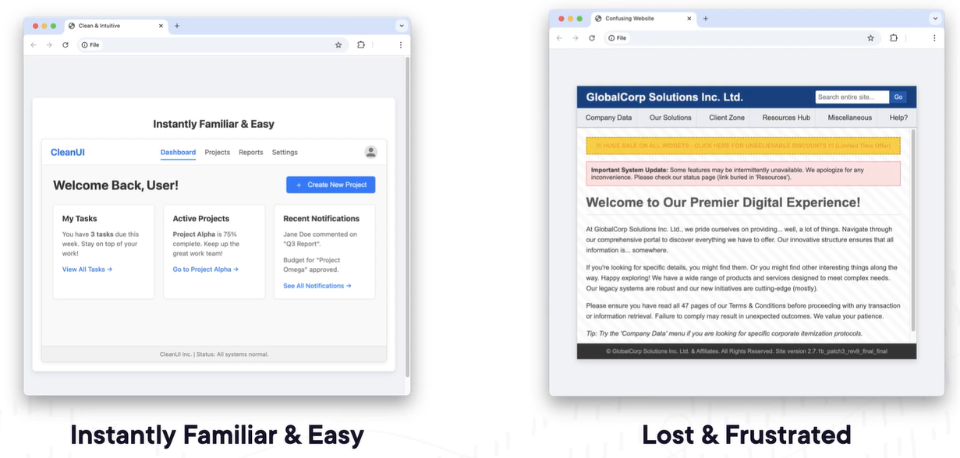

We should organize content by what the user wants to achieve like transfer funds, pay bills, deposit check.

Task-based vs. Topical –

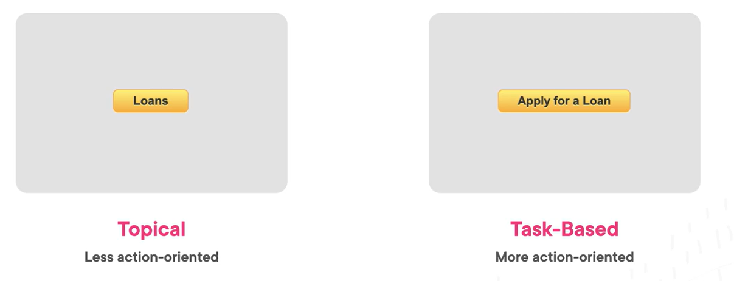

Structural patterns – hierarchical structure –

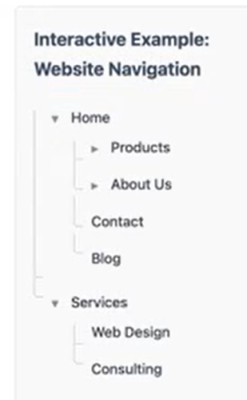

Sequence (Linear) structure – user progress in defined structure. It provides strong guidance but offer less flexibility for exploration compared to a hierarchy.

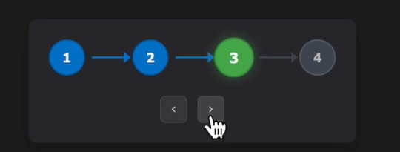

Matrix structure – users effectively create their path by applying filters relevant to their specific needs. Useful for large product catalog.

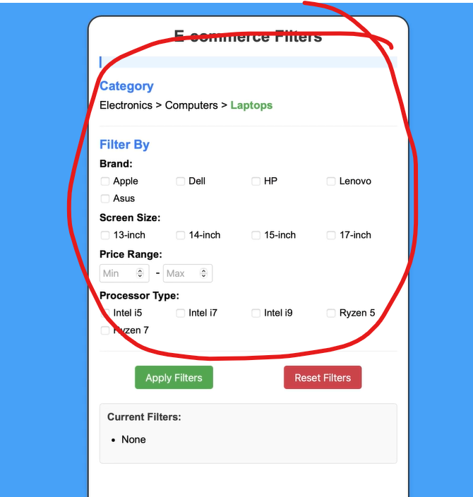

Global and local navigation –

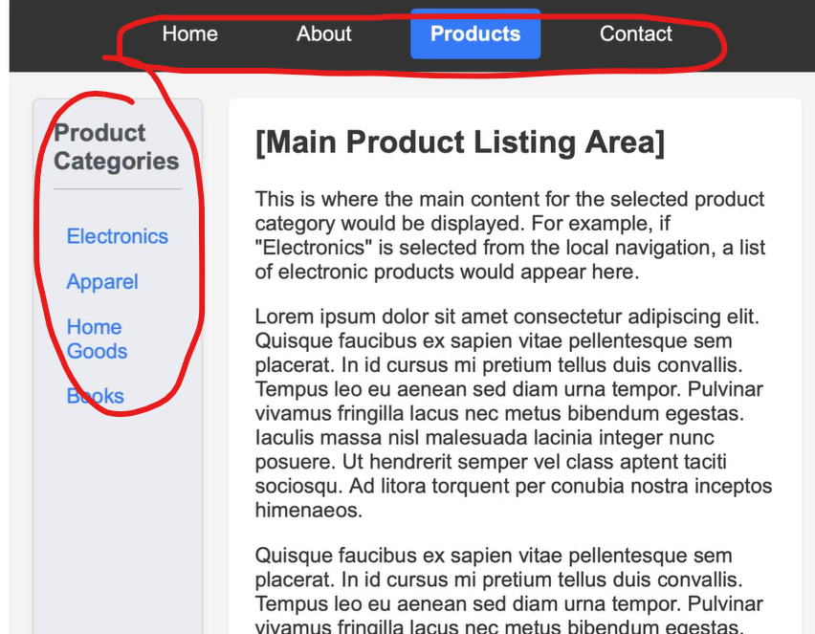

Utility navigation like login in, logout, site search, help/support, settings/preferences –

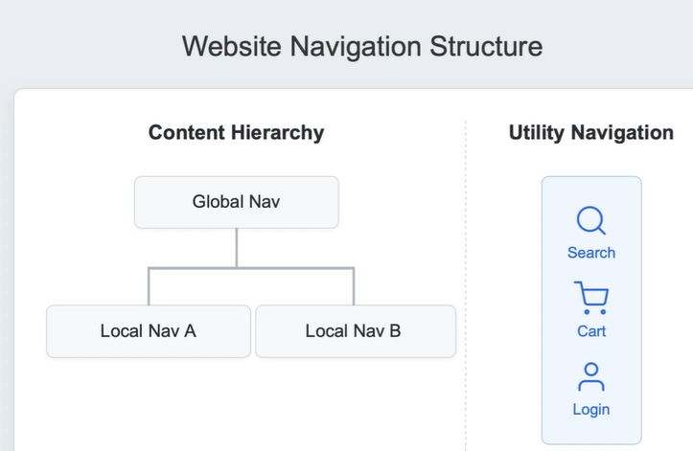

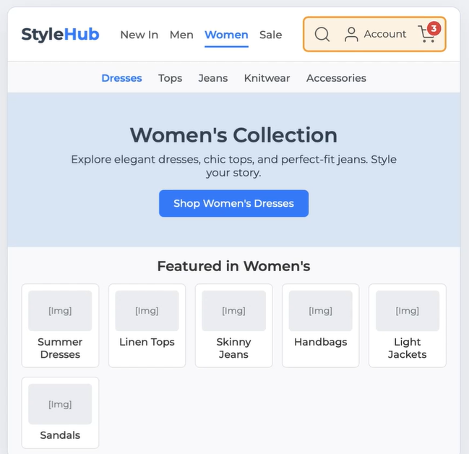

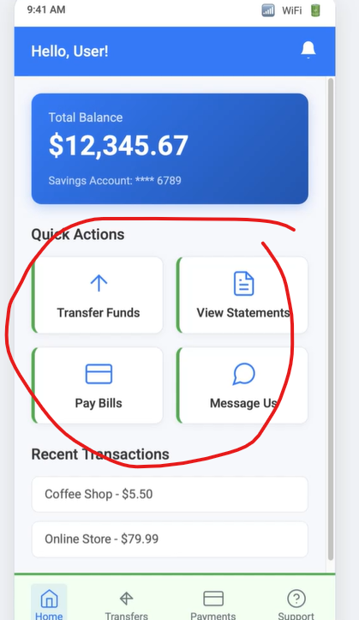

Contextual navigation – linkes

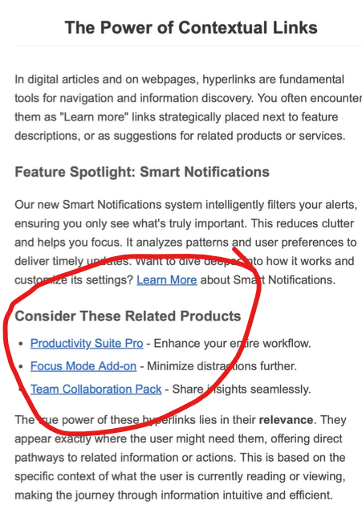

Supplemental navigation – breadcrumbs. Provides additional orientation cues.

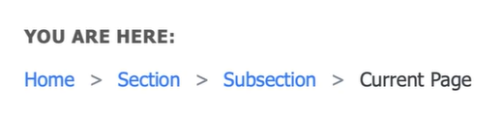

Instead of this – complicated navigation

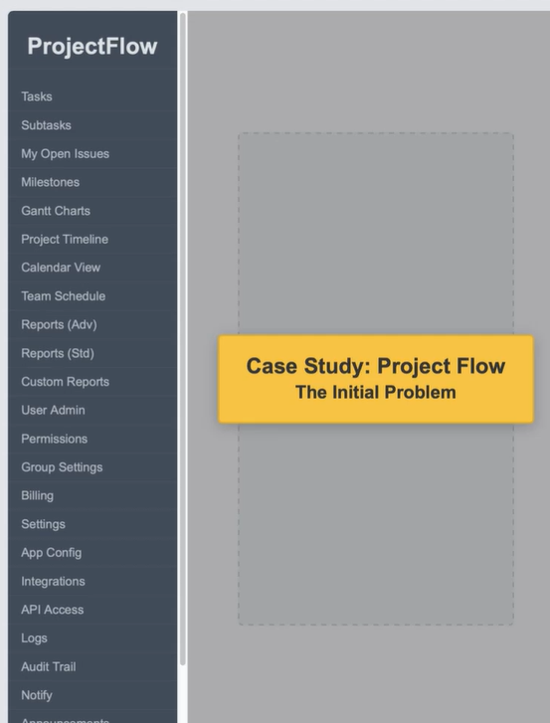

Use task based approach for clean UI –

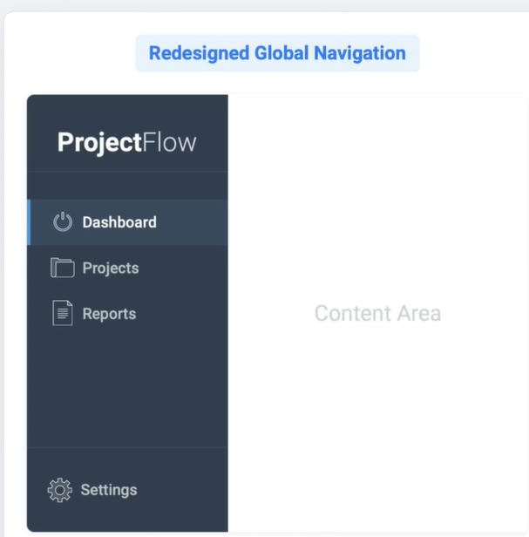

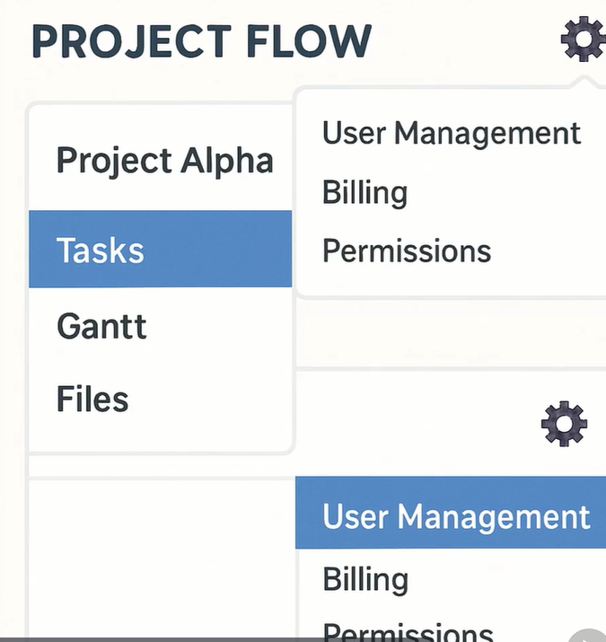

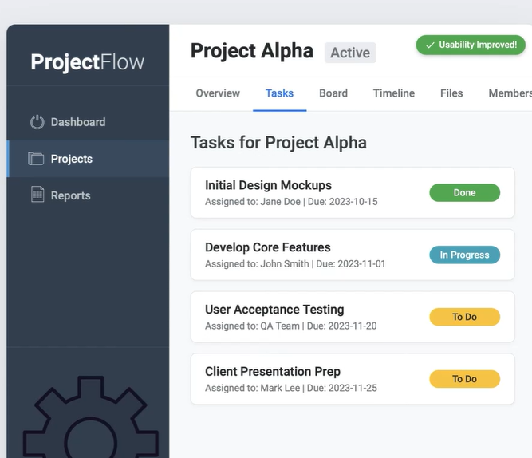

The impact of inconsistency – wasted time, user confusion, errors and misinformation.

When there is no result from search, show helpful suggestions instead of blunt dead end –

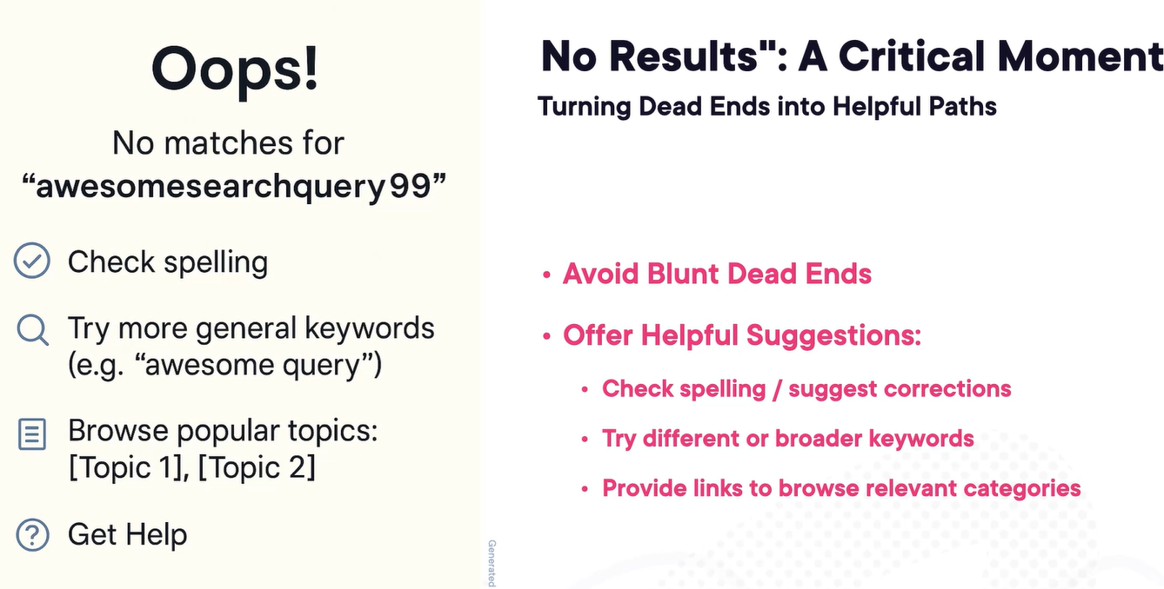

## Web Components: Shadow DOM Deep Dive

Web components let us use JS APIs to build custom HTML elements that behave like native HTML elements. It promotes the idea of encapsulation example – checkbox component. Shadow DOM is designed to enable us to create reusable, encapsulated custom elements that can be dropped into any number of environments and still behave predictably.

Light DOM vs. Shadow DOM -global scripts and style won’t cross the shadow boundary unless we specify to.

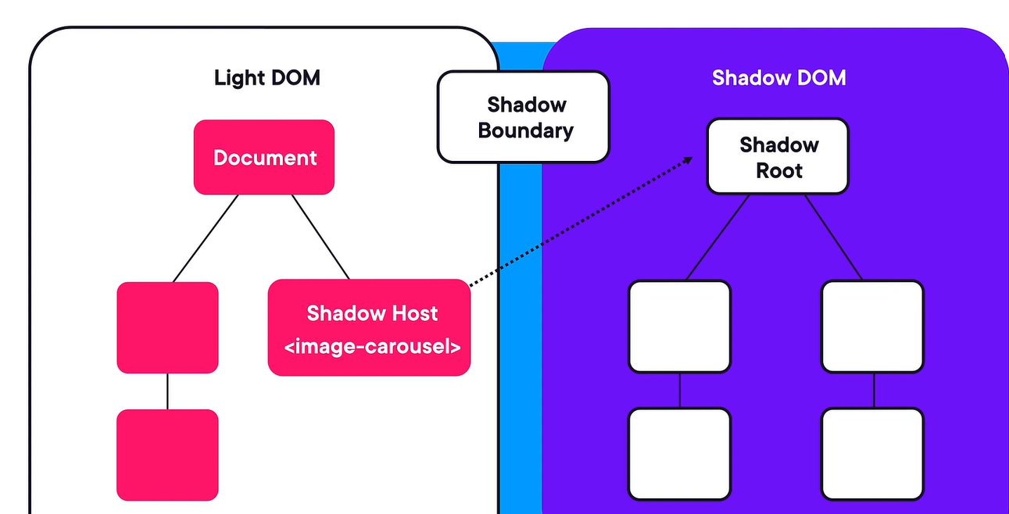

Custom banner element –

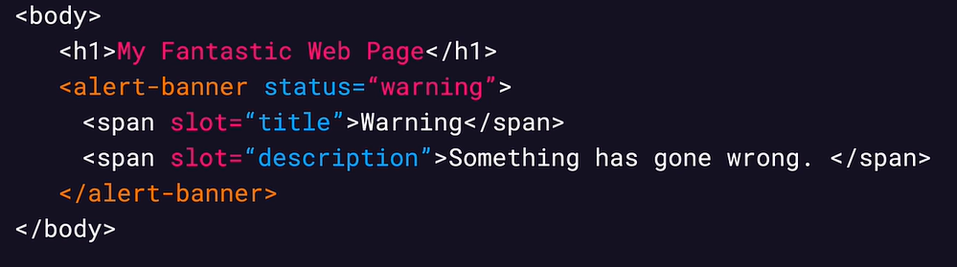

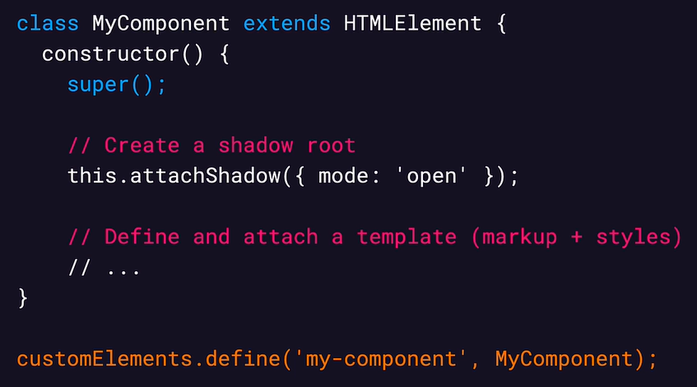

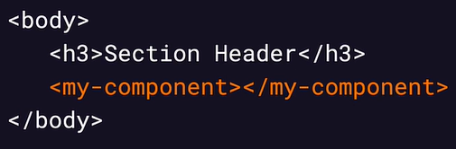

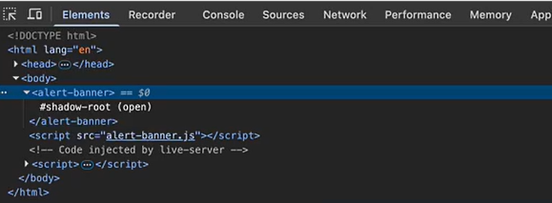

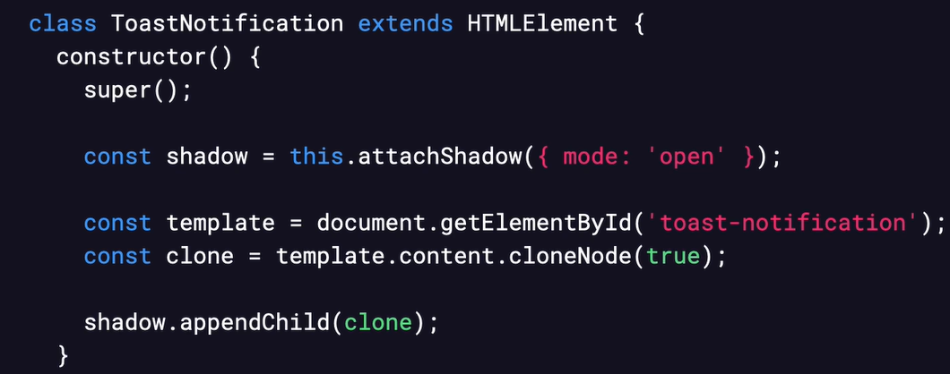

By appending the content into the template, we are making our template reusable –

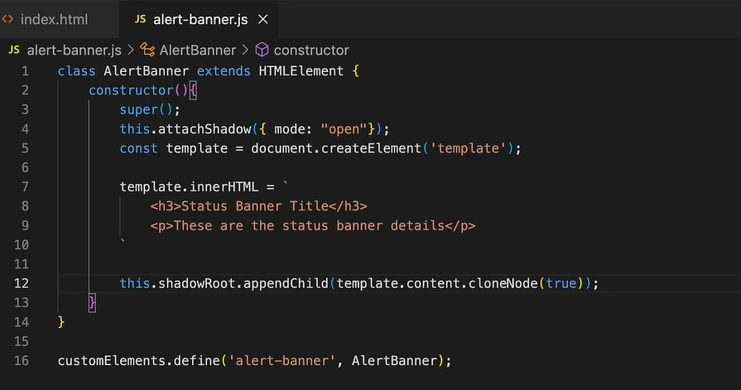

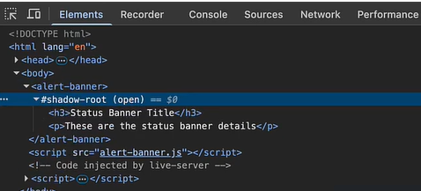

Slots let user pass their own text or HTML elements into our custom component. It makes the component customizable but expose their content to outside world as the global script and style will impact them. Slots are meant to be customizable entry points and that’s why they always exist in the light DOM –

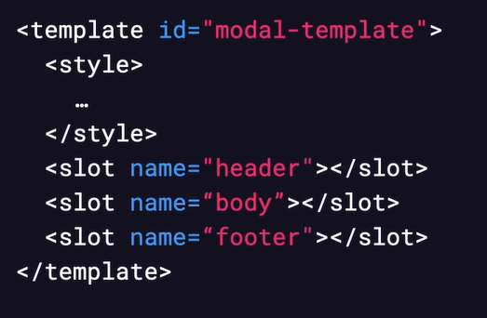

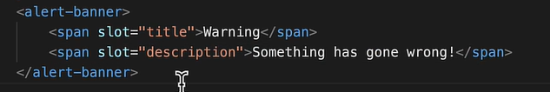

We can style shadow DOM elements using attributes and we can style the documents through this provision intentionally from outside DOM. With this we made an interface that allows users to customize styles without having to dig too far into custom element’s internal. Through using the host pseudo class and targeting attributes in the CSS we are able to apply internal styles that stay contained within the component –

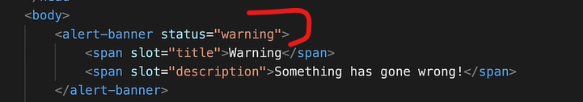

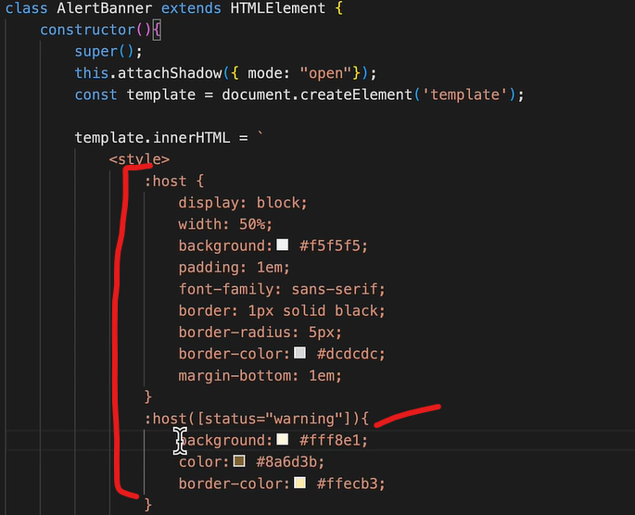

But above CSS style code will be applied to all the shadow DOM elements repeatedly which cause duplication. We can avoid this by using constructible stylesheet, it will be shared among many shadow roots without duplication.

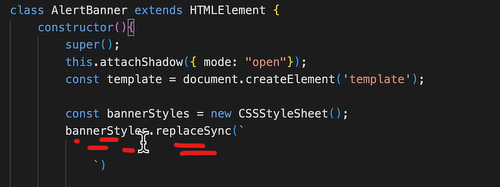

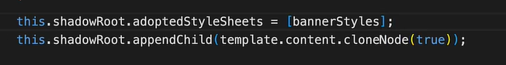

The host, host-context and slotted – with ::slotted pseudo element, we can directly target the style slotted content without having to use specific class names. With host-context selector we can set styles based on the context around it like setting dark or light mode.

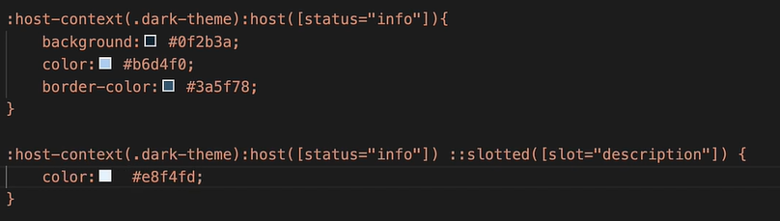

Whenever a event get raised from the any inner element of the shadow DOM, it will shows the targeted element as shadow element not the actual inner element. This is because concept called event retargeting, in which to preserve encapsulation, events crossing the shadow DOM boundary are retargeted to the host element, so code outside the shadow-root can’t directly see or interact with internal elements through events. If we wantt see the full path then we need to use “.composedPath()” method –

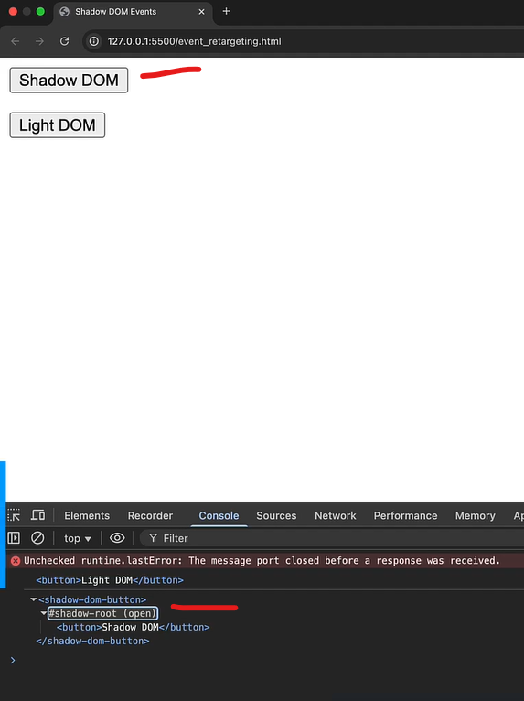

To let the browser give you access of shadowRoot element, we need to use mode as “open” which attaching the shadow element.

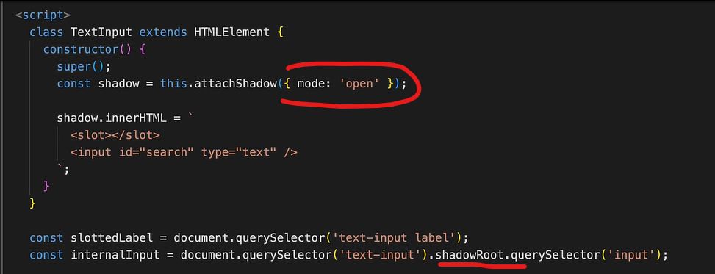

Writing a custom event using connectedCallback() and disconnectCallback() as a lifecycle hooks – example to let the Light DOM know, which inner shadow DOM element raised the events.

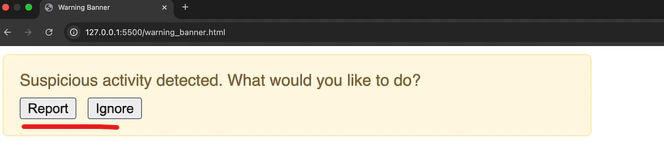

On Shadow DOM raise these events –

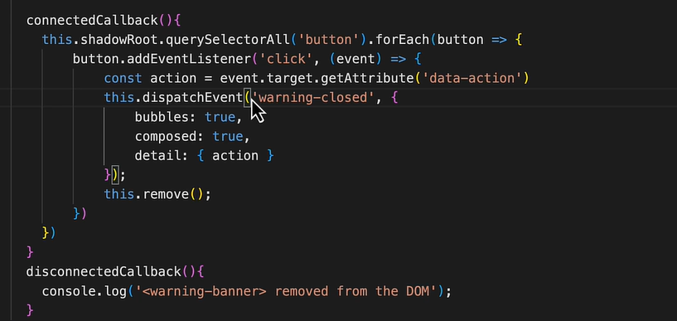

On light DOM to listen these events –

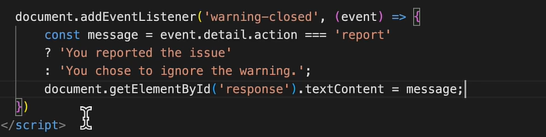

## Screen Reader Compatibility Testing for Web Accessibility

Additional assistive technologies other than screen readers are refreshable braille display, screen magnification glasses, specialized keyboards, simple switches, voice assistants. People are aware of screen readers because it has a low entry barrier (easy to install software).

Most people don’t use screen readers from top to bottom but they look for headings and then further deep dive into its content according.

Screen reader mode – browse mode – it is a default mode and allows people to navigate and discover content easily. Provides the largest amount of available keyboard shortcuts.

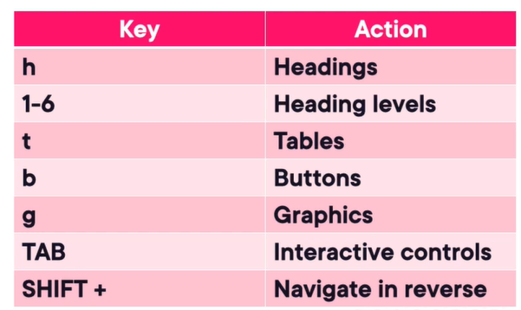

Another mode is forms/focus mode – browser will auto switch to this mode on applicable content, this mode is required to interact with form elements, key presses are passed straight to the browser. Forms mode allows people to type words into form.

Last third mode is application mode which is combination of browse and form mode in a specific context i.e. used for custom components. Because in case of custom components interactions are not provided by the screen reader or browser, it needs to be provided by the custom component in JS like interacting with toolbars or horizontal menus with LEFT/RIGHT arrow keys or ESCAPE key to dismiss modal dialogs.

Don’t assume all screen readers sound the same, they announce different things at different times and in different order with different levels of details.

By default, most punctuation is silent. Screen readers will provde a silent pause when encountering most punctuation.

Ensure acronyms or abbreviations are accompanied by fully expanded version because screen readers might pronounce the abbreviation correctly.

Testing with NVDA (nonvisual desktop access) – it is free for windows.

While using NVDA tool, use best practice settings from <https://app.pluralsight.com/ilx/video-courses/clips/42ba6221-ef2c-4591-8ff1-28e41a8e8662>

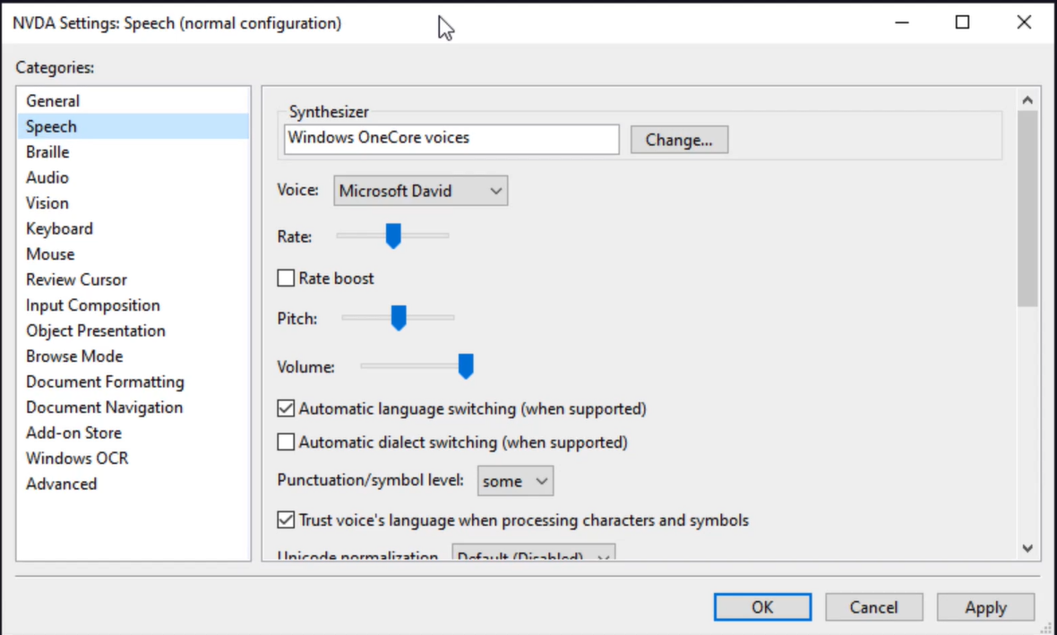

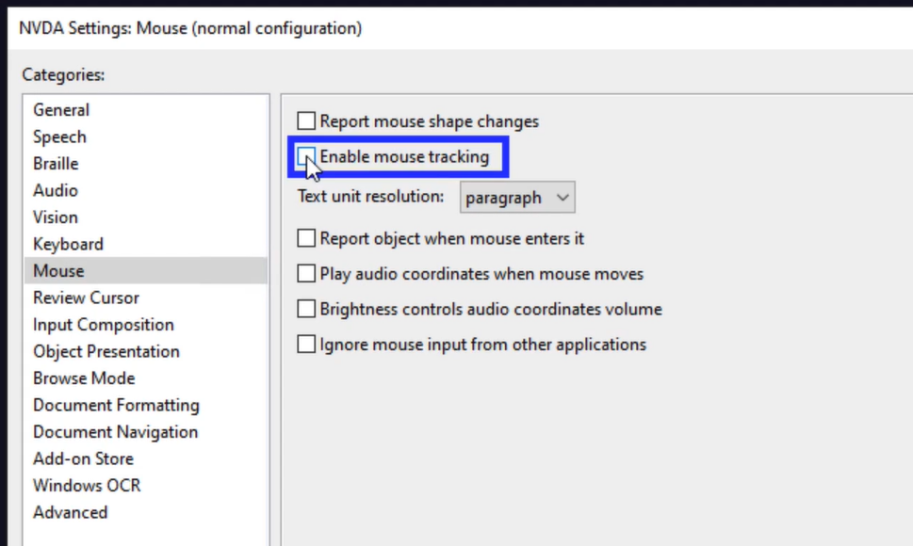

It also gives speech viewer

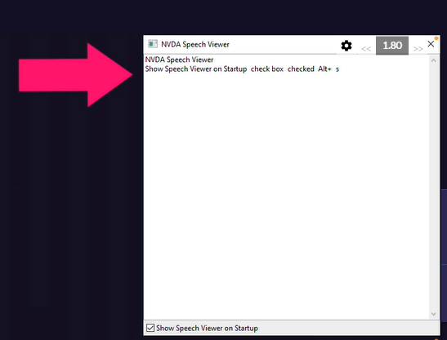

It will give name, role and value information in sequence –

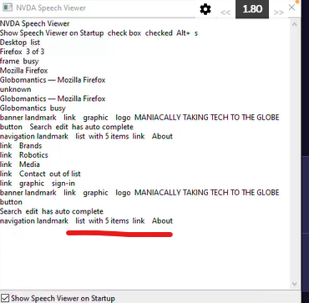

Give demo like this one in a11y presentation –

<https://app.pluralsight.com/ilx/video-courses/a4421625-4d01-42cb-8fdb-c0ae859862f7/10f563d1-bd04-4e67-a5f0-9abf3822def1/149d30db-aea4-4fe9-b5be-c7289eb65fa7>

We can navigate the page using arrow key or tab key, the tab only navigates to interactive or focusable elements but skips over all the static content.

Instead of installing a software on machine, we can use the tool like <https://assistivlabs.com/> to test the website remotely. Use this link to get 6 months of free trial - <https://assistivlabs.com/sign-up?promo=gerard.cohen>

Keyboard shortcuts for NVDA –

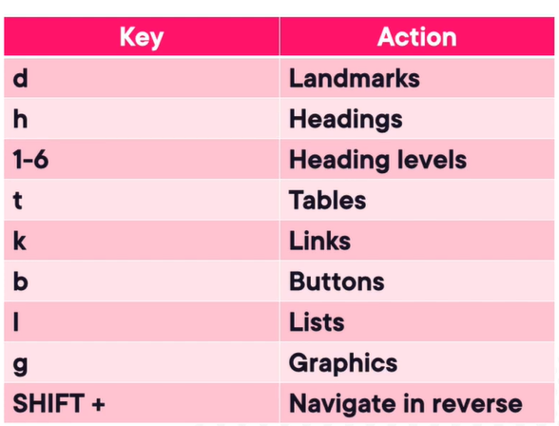

There should be at-least one landmark on the page i.e. “main landmark”. Navigating by landmark gives a person using a screen reader an easy way to bypass blocks of content like straight fully going to the footer landmark by just pressing “d” button.

We move from cell to cell horizontally in any direction we need to use ctrl + alt and arrow key, otherwise just use down array to read the table sequentially.

Using elements list, it will us the access of all the elements of specific types to navigate like links, headings, form fields, buttons and landmarks. It is a fast way of verifying labels and elements types. We can bring the elements list by using NVDA and F7 keys –

Best practice use Elements List tab to quickly check for elements for a11y for any labels and semantics issues or like if something we expect to be a button but found in links category then we know that the role or the semantics are off -

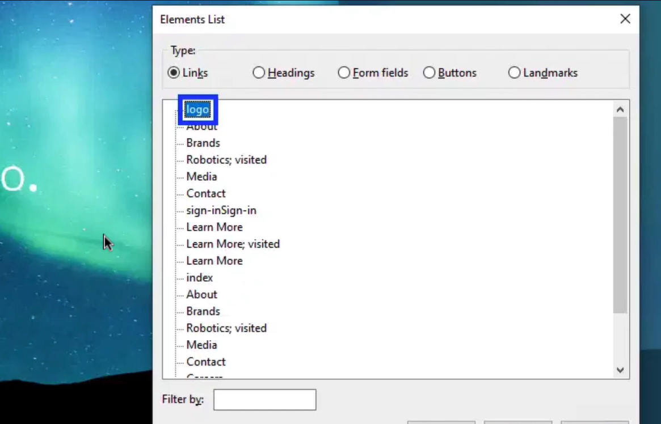

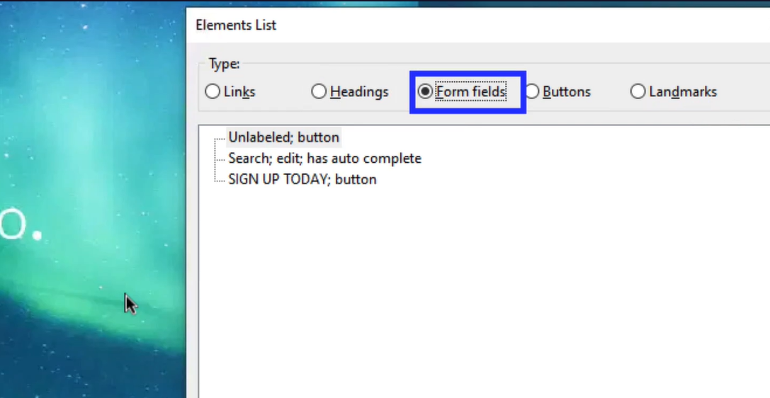

When we focus on any element, it should give us three information i.e. label (name), type (role) and state (value).

There is another screen reader named JAWS (Job access with speech), it is not free and require license.

For macOS and iOS, we can use VoiceOver tool which is free. There is no concepts of modes unlike NVDA in VoiceOver. Basically when we use VoiceOver key it will like working as Browse mode and without VoiceOver key it is like Focus Mode. So it is not done automatically unlike NVDA but through whether you use the VoiceOver key or not.

Gesture Navigation – by using swipe and taps we can navigate the content in the mobile devices.

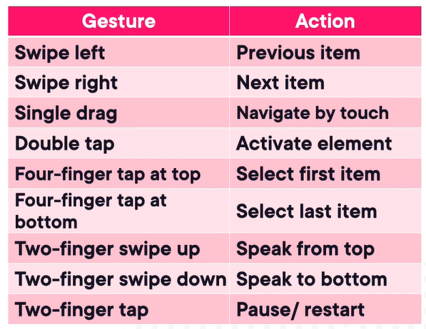

We can bring the web rotor on the iOS by using two-finger twist gesture and use swipe up and down to navigate further –

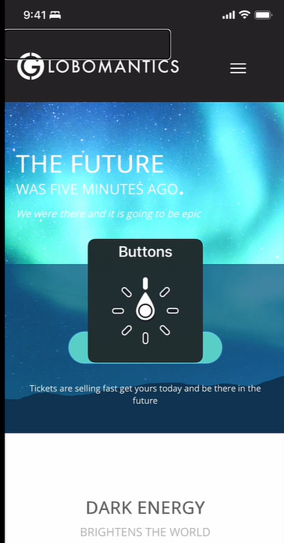

We can also test the iOS with keyboard.

Testing with Talkback on Android – if we don’t have a physical Android device, we can use the emulators included with Android Studio. Use recommended settings for good test experience as per <https://app.pluralsight.com/ilx/video-courses/a4421625-4d01-42cb-8fdb-c0ae859862f7/c638aa88-912b-4972-996b-9fd04d619dcf/f394cef6-c6fb-40aa-b9bc-094fc8f450a7>

Gesture Navigation –

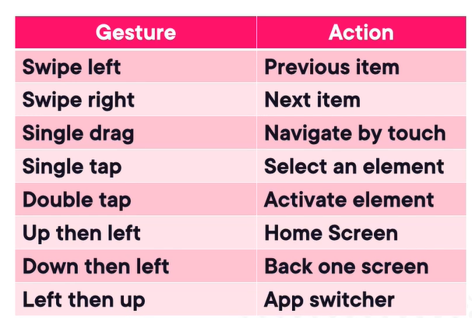

Reading controls menu like web rotor in iOS –

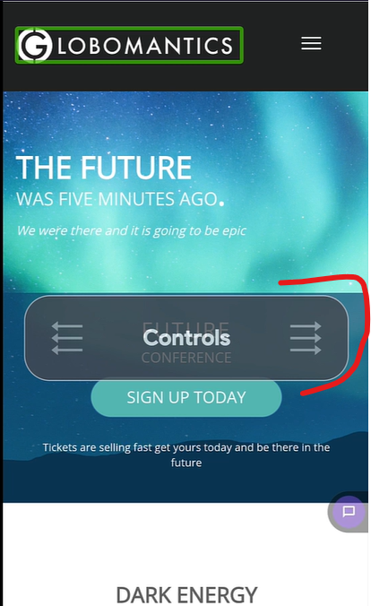

Bringing talkback menu –

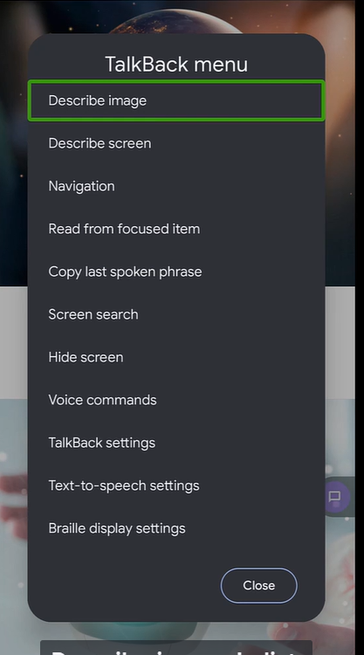

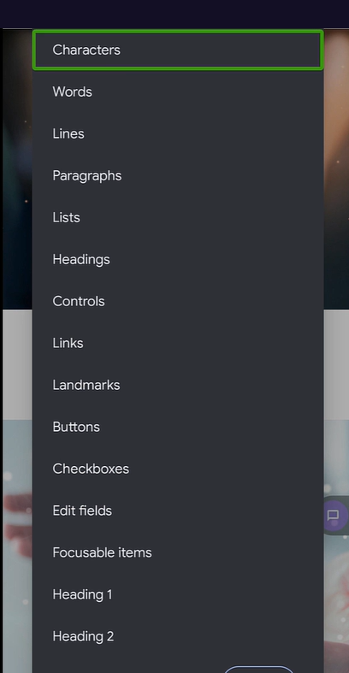

We can connect a Bluetooth keyboard to any android device. Unfortunately, this doesn’t work so well with the Android Emulator but with physical devices.

## Web Components Foundations

Web components are framework but combination of three web standards – custom elements, shadow DOM, HTML templates (performant reusable chunks of markup that aren’t rendered until we need them). They are just framework agnostic components.

Custom element registry – upgrade can be used to update the custom element in the parse tree manually in case of lazy loaded custom element –

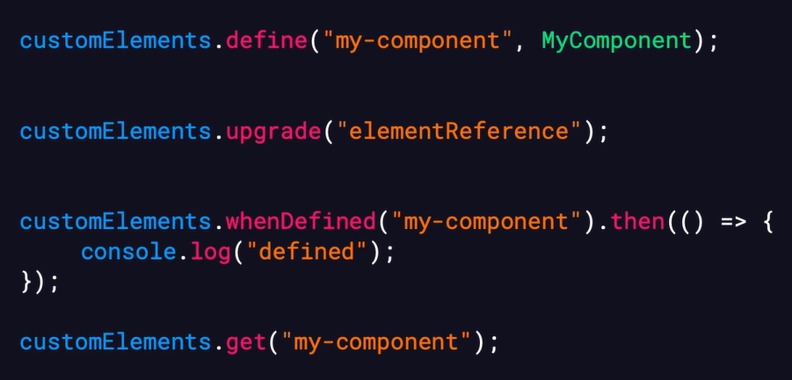

Life cycle callbacks and their sequence –

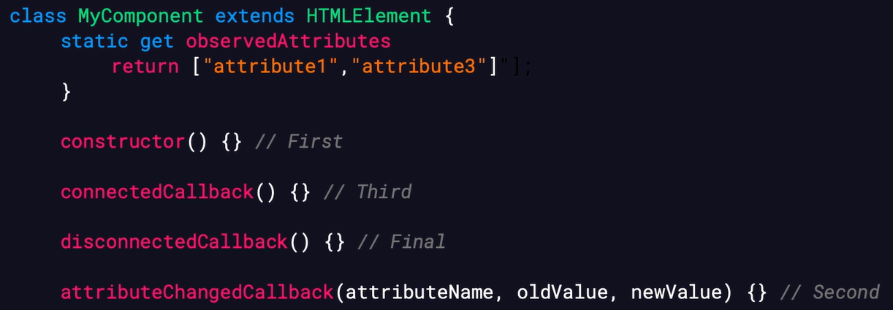

Attributes vs. properties – attributes are always strings type and their JS properties accessed via dot notation can take any JS value as web components follow HTML standards

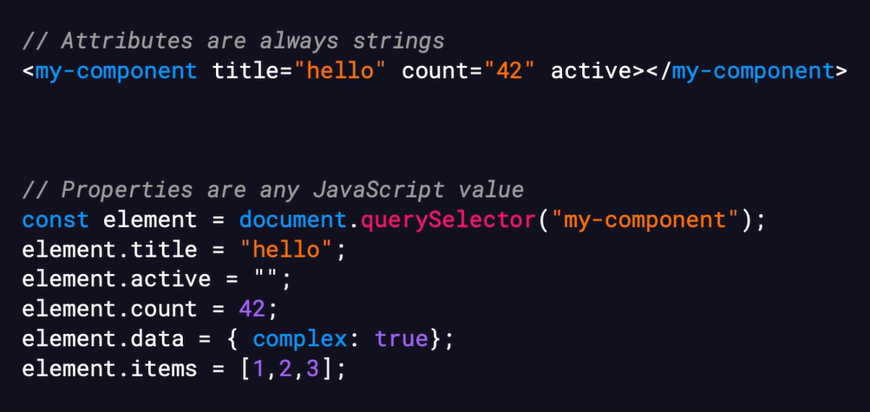

Don’t use JSON strings in the attributes but rather than this use child elements or JS properties for agnostic behavior –

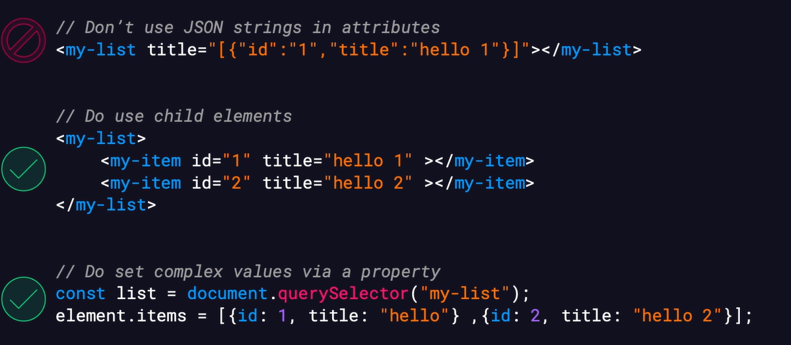

Reflection – whether we want or not to properties with attributes to be reflected on change –

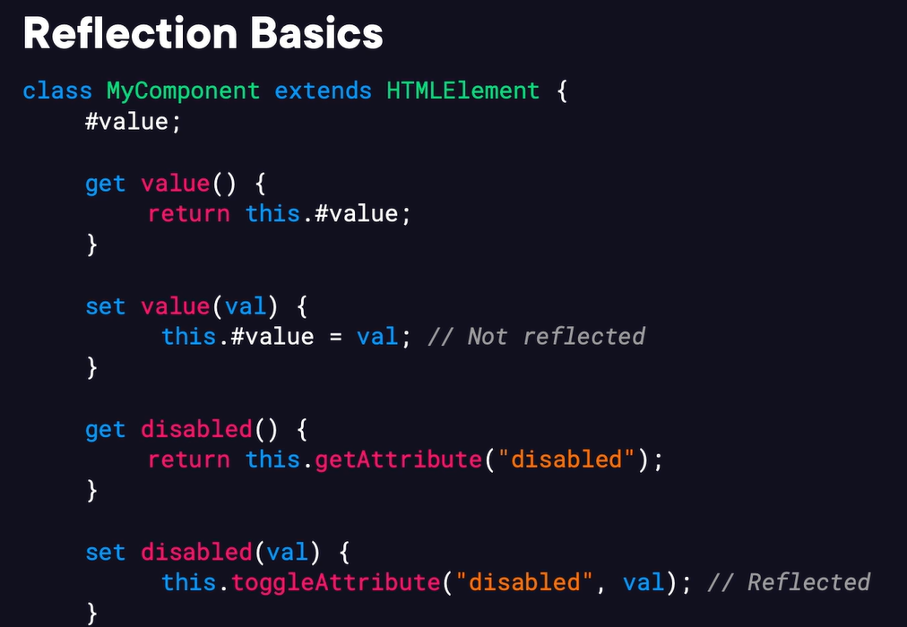

Shadow DOM – what can cross and what can’t –

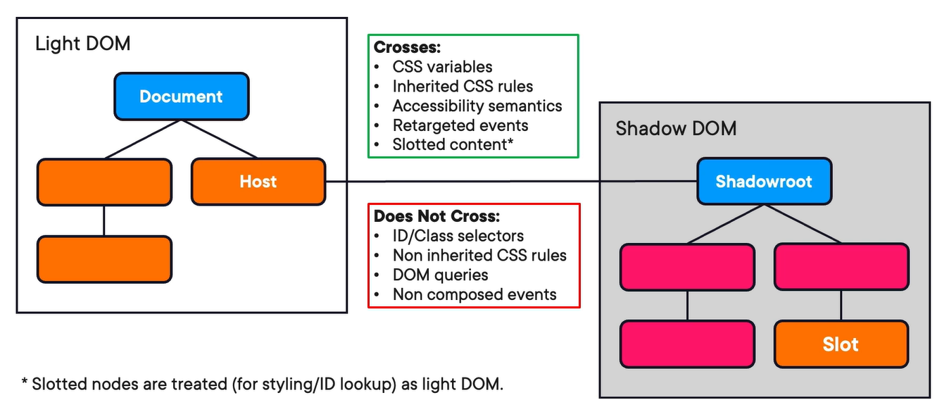

Ways to make shadow DOM – imperative and declarative (new way to allows shadow-roots to be defined in HTML markup, making server-side rendering possible) –

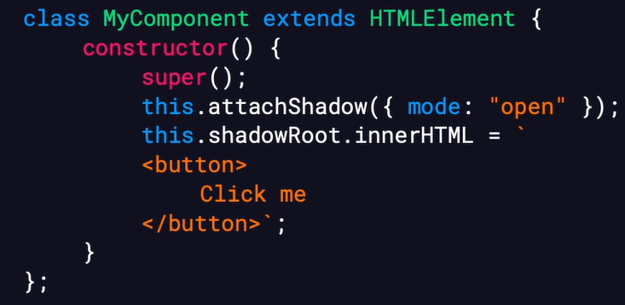

Web component styling – from the inside and from the outside –

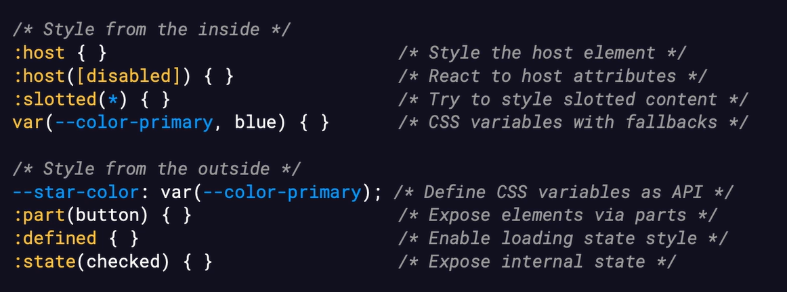

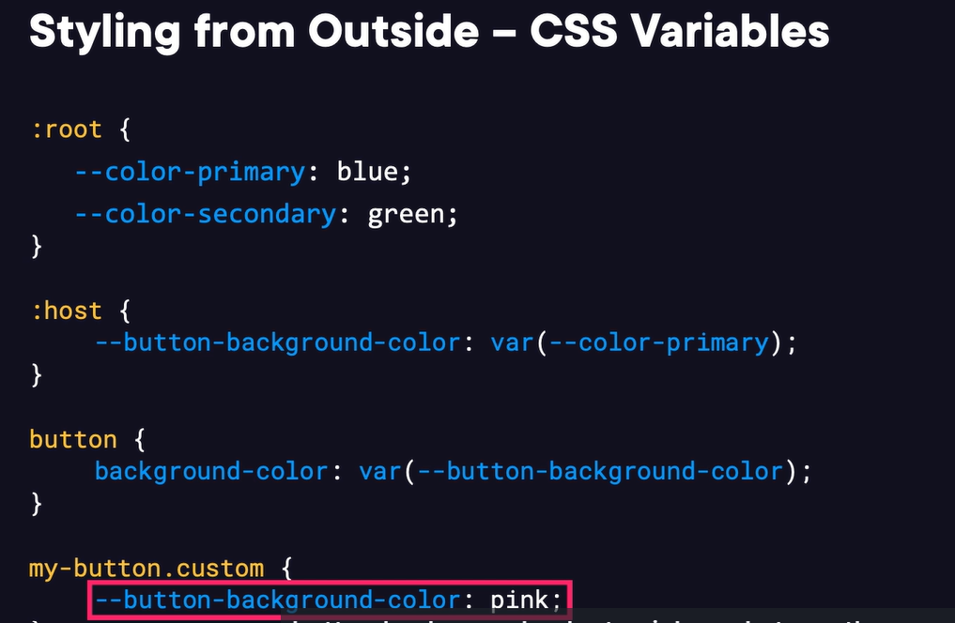

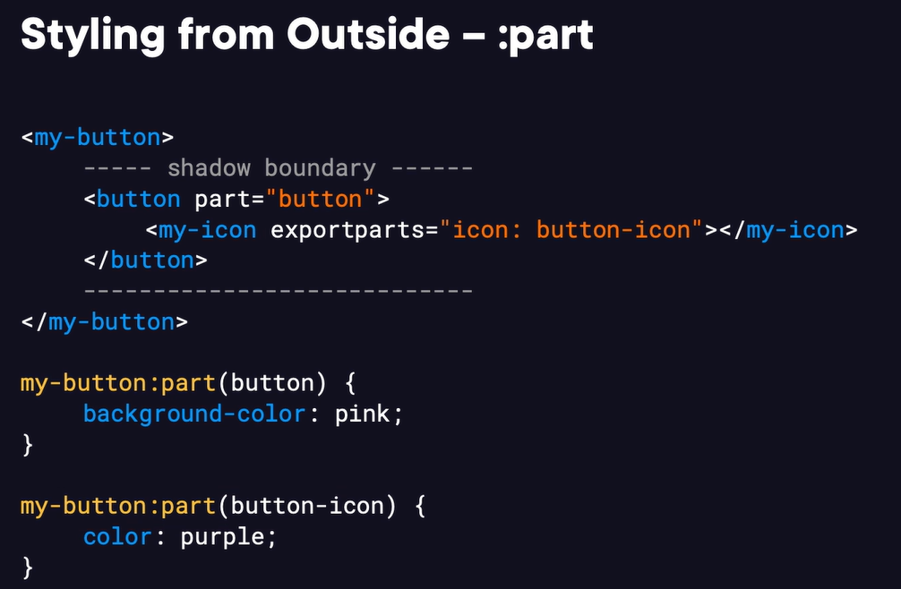

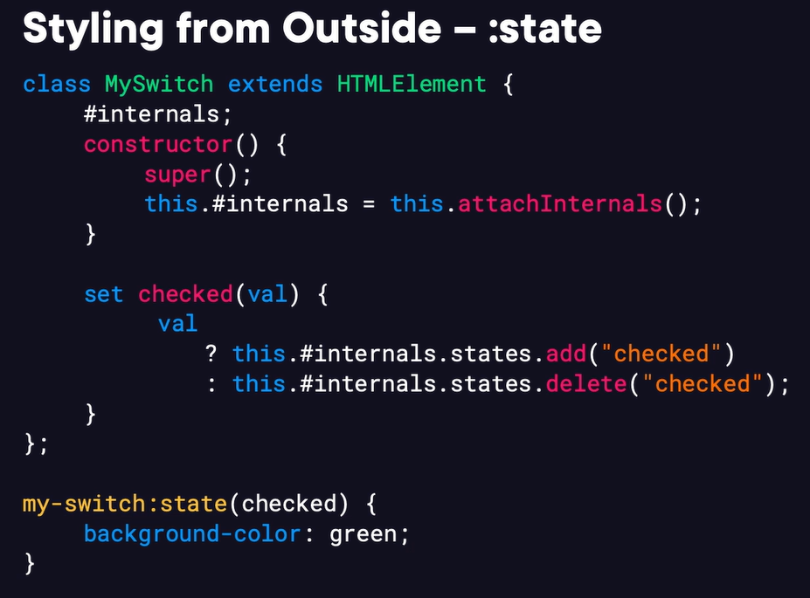

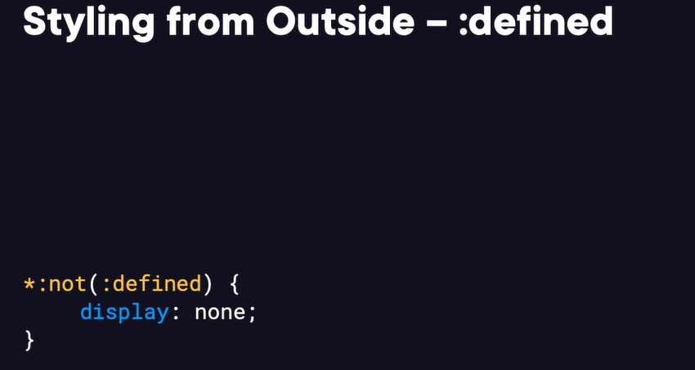

Inherited styles that cross shadow boundaries –

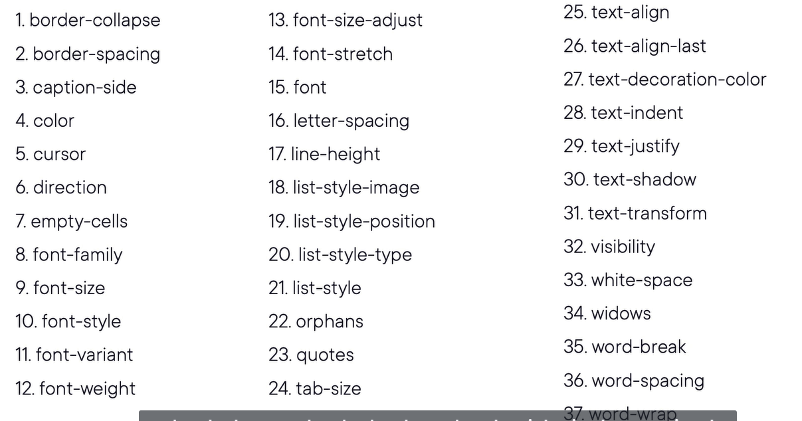

HTML template – it is third web component API. The template element hods innerHTML, it doesn’t render, doesn’t load resources nor run scripts. It is dormant until we clone and use it. Templates are more efficient that in an HTML for repeated content.

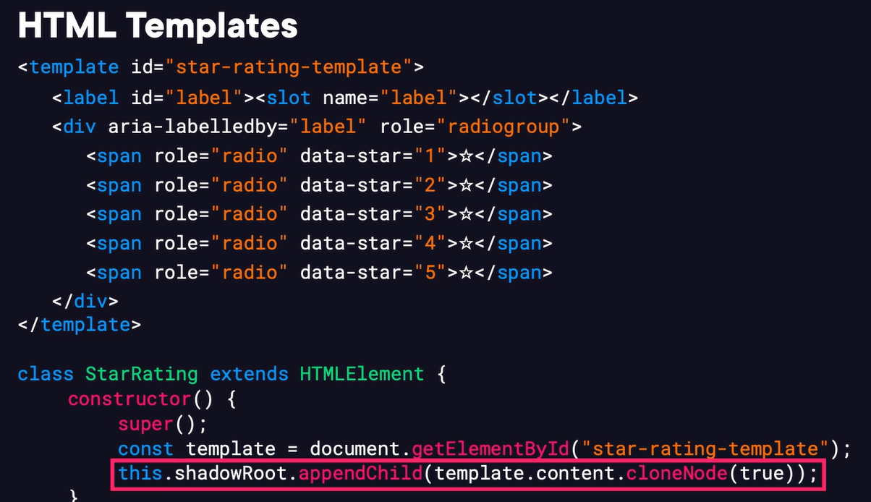

Declarative shadow DOM – by using shadowrootmode as “open”. It enables server side rendering.

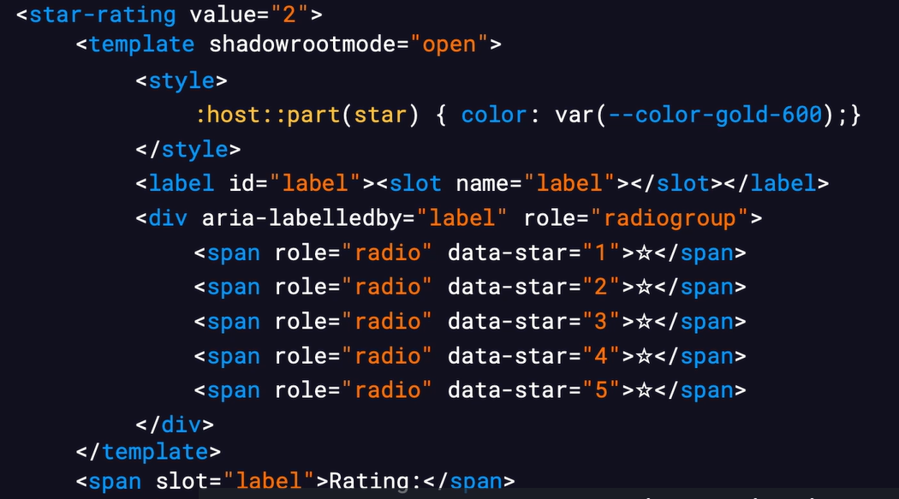

Element internals – it is a JS API that gives custom elements access to browser internals previously reserved for native elements like form association (submit values, validate, reset, all standard form behaviors), a11y object model, custom states.

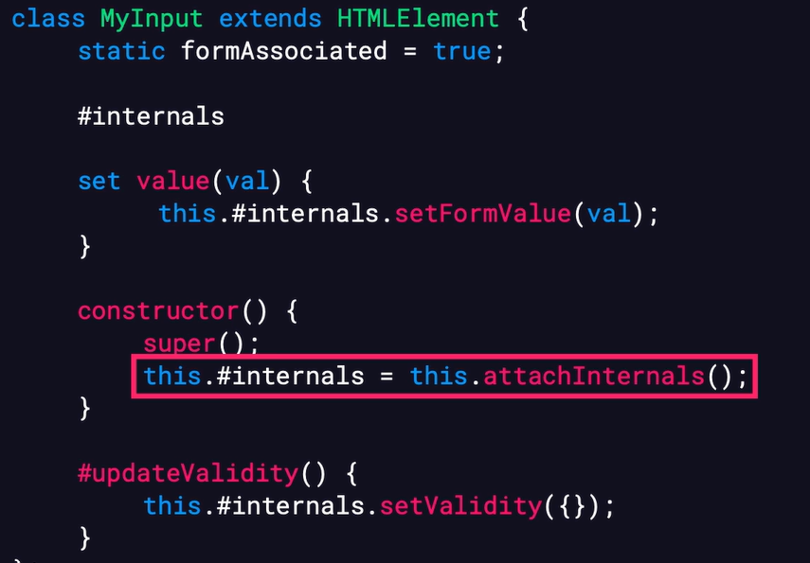

All available form API options –

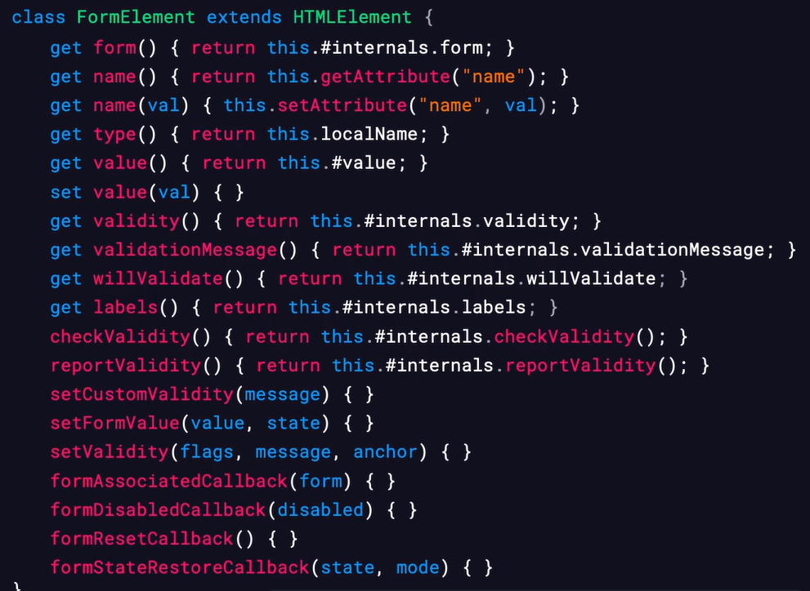

Practice – To create a 5-star rating custom component, using custom elements, shadow DOM, HTML templates, element internals, watch this course - <https://app.pluralsight.com/library/courses/web-components-foundations/table-of-contents>

## Bootstrap Foundations

Building blocks – layout, components, interactivity, style utilities, theming support.

Bootstrap grid system – it all started with a table but it didn’t scale well and most sites use a table-like structure through, so bootstrap uses Grid which is kind of modernize version of table. It has few key concepts first is container which it is what kick off the grid. It wraps our content and sets the boundaries for our layout, inside the container we define rows and columns, another concept is breakpoint which represents widths on which layout will “adapt” to different arrangement. It is foundation for responsive design. Under the hood they are based on media queries.

Available breakpoints –

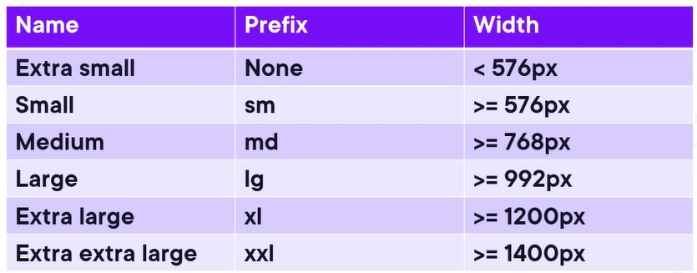

Different type of containers – regular, fluid and responsive (start with regular then become fluid)

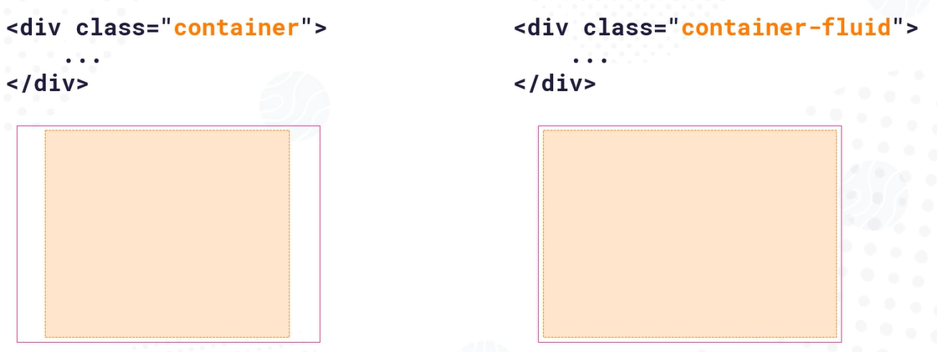

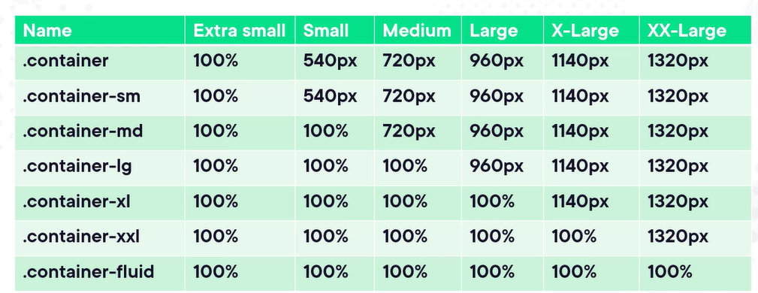

Adding rows –

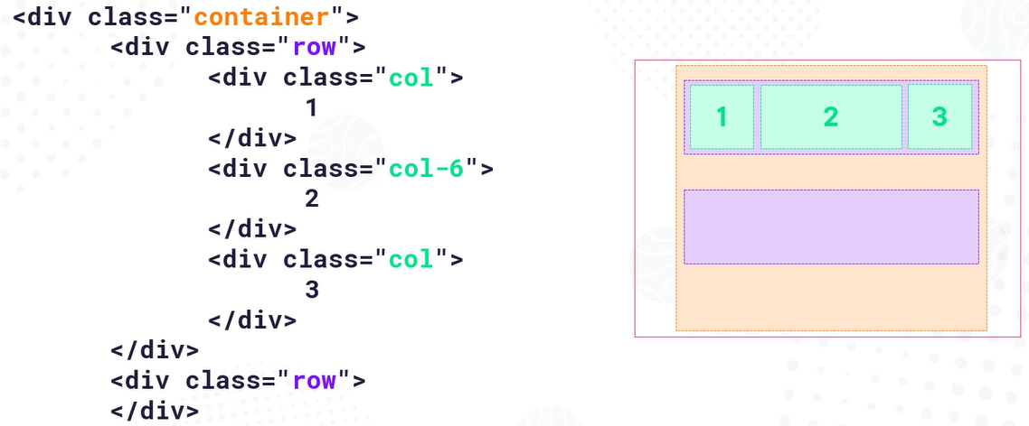

By applying the “order” property we can change the order of the columns on the UI –

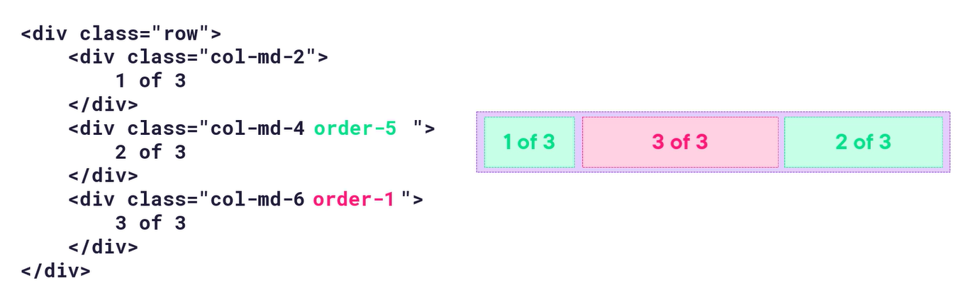

We can leave intentional gaps between element by using “offset” property, it reserves space without placing content there –

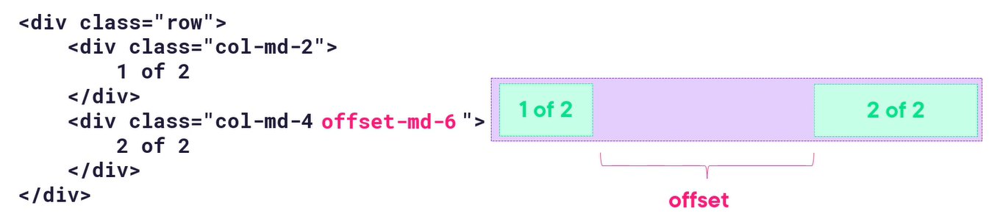

By using “gutters” we can add spacing between the columns and grid. By default, bootstrap adds default horizontal padding between columns, we can adjust this spacing using the “gx” classes, for vertical spacing use “gy” class instead –

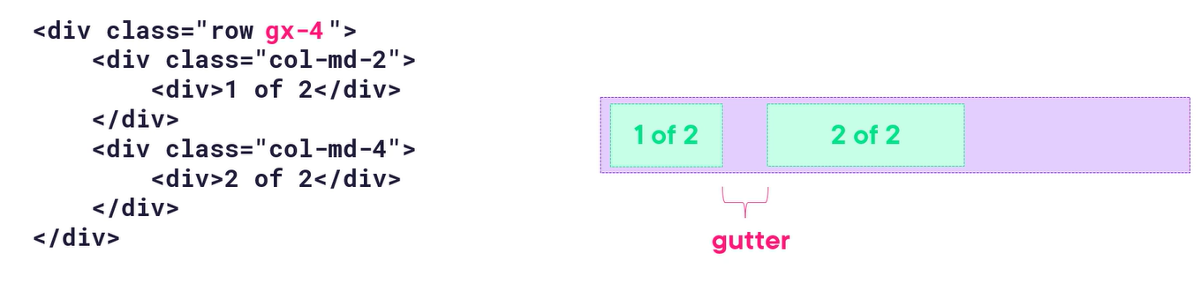

Built-in classes for working with text - Adding style with bootstrap with built-in classes – display-1 to display-6 for headings, text-center, text-start, text-end, text-sm-start-, text-wrap-, text-break, text-primary, text-white, text-capitalize, fst-italic, text-decoration-underline. The lead class will apply emphasis.

Built-in classes for working with tables – table, table-dark, table-light, table-success, table-warning, table-striped, table-bordered, table-hover, table-responsive.

Built-in classes for working with images – don’t give a image a fixed width instead give class img-fluid, rounded, rounded-3, rounded-pill.

Built-in classes for layout – mt-1, pb-3, p-3, me-3 (margin to the end of the element i.e. right side in a right-to-left layout), py-5 (padding vertical), border-border-bottom, border-primary.

Built-in classes for icons – bi-gift, text-success.

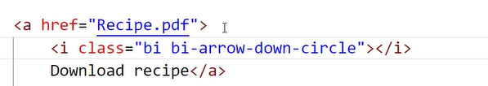

Built-in classes for colors – text-primary, text-secondary, text-success, text-danger, text-warning, text-info, text-light, -text-dark, text-muted, text-white.

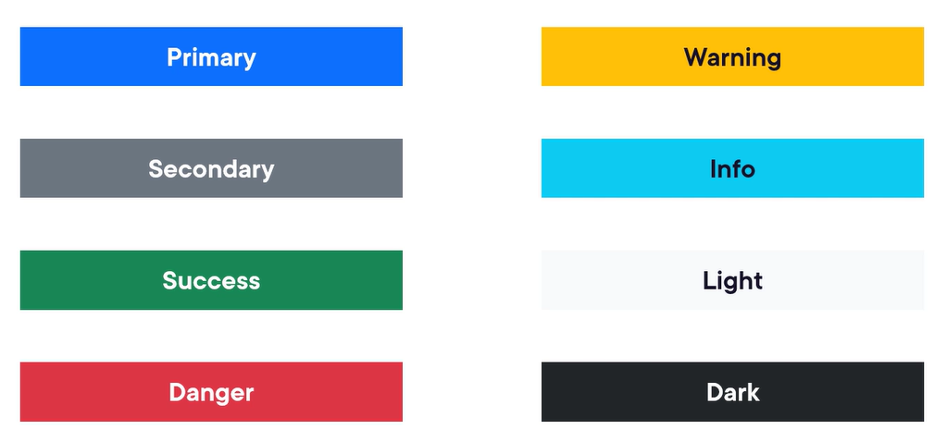

Bootstrap components –alert, button, breadcrumb, nav and navbar, card, progress bar.

Using nav component – it can be tabs, pills or dropdown layout options. We can also use navbar class which is built on nav but responsive specially for mobile menu -

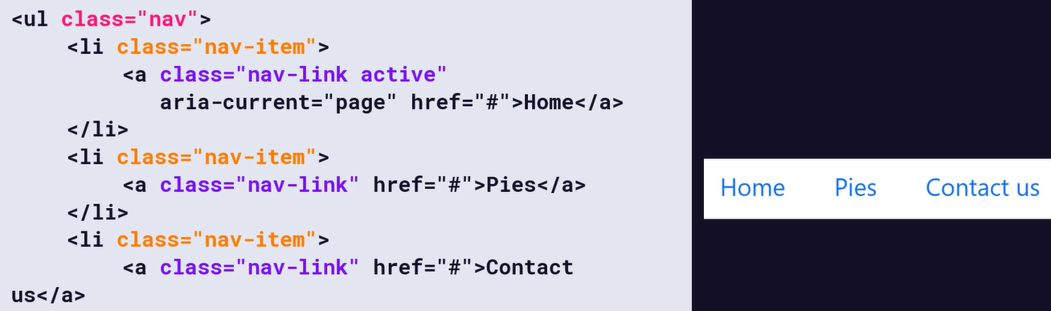

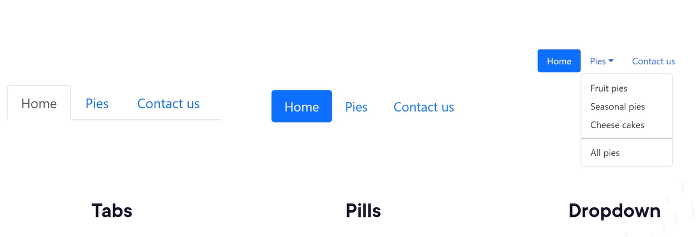

The navbar sub-components –

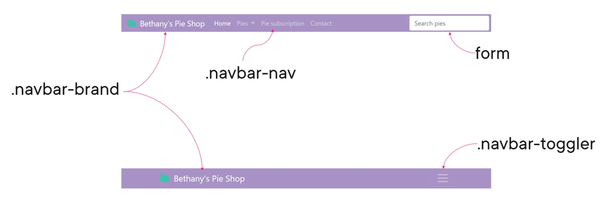

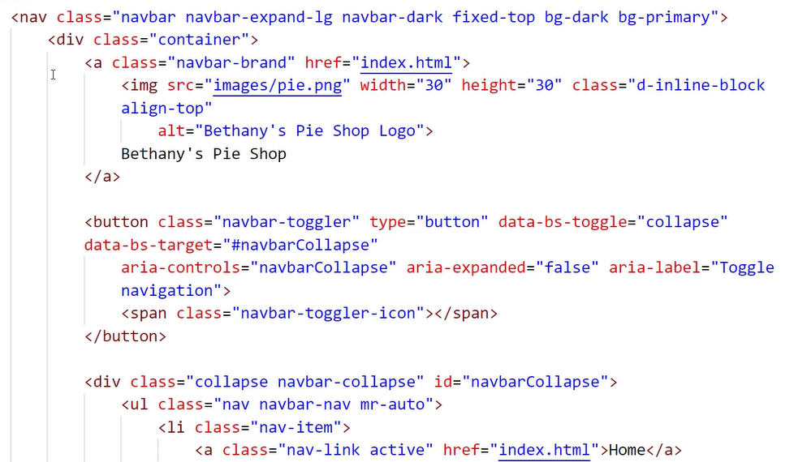

Using the different card component options –

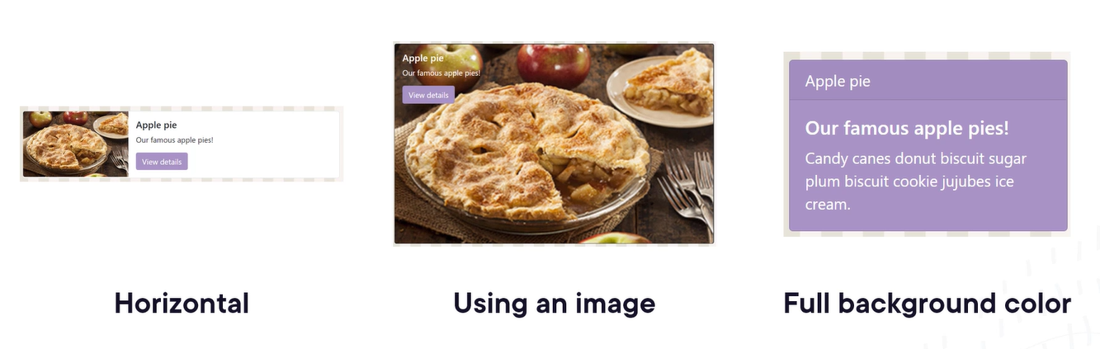

Creating form with bootstrap components – for checkbox and radio we have special classes for their correct layout. Relevant classes for Forms – form-control, form-label and form-text (supporting or explanatory text) –

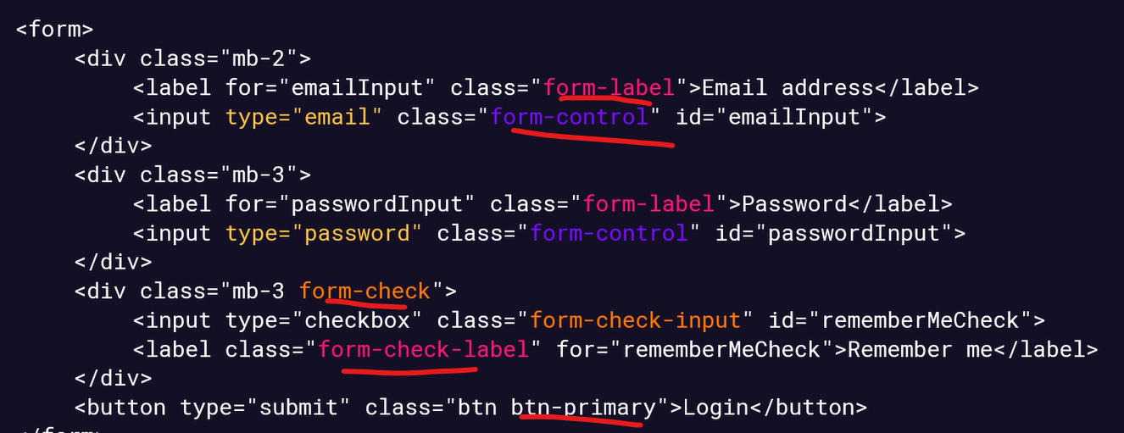

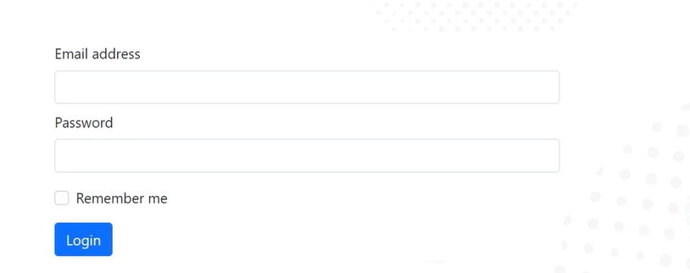

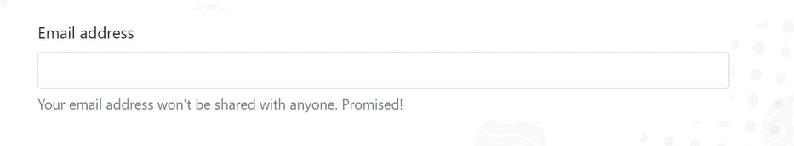

We can use classes like form-control-lg or form-control-sm to make the form control larger or smaller –

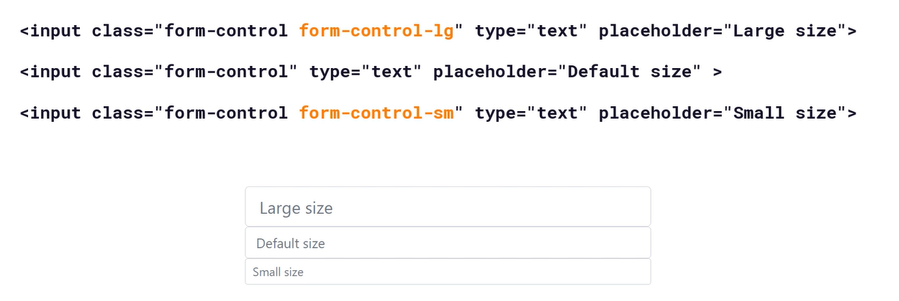

Save the bootstrap cheat sheet for quick reference.